United States
Securities and Exchange Commission
Washington, D.C. 20549
FORM 8-K
Current Report
Pursuant to Section 13 or 15(d) of
The Securities Exchange Act of 1934
Date of Report (Date of earliest event reported): September 11, 2023
RCI HOSPITALITY HOLDINGS, INC.
(Exact Name of Registrant as Specified in Its Charter)

Texas |  |  | 001-13992 |  |  | 76-0458229
(State or Other Jurisdiction  of Incorporation) |  |  | (Commission  File Number) |  |  | (IRS Employer  Identification No.)
10737 Cutten Road
Houston, Texas 77066
(Address of Principal Executive Offices, Including Zip Code)
(281) 397-6730
(Issuer’s Telephone Number, Including Area Code)
Check the appropriate box below if the Form 8-K filing is intended to simultaneously satisfy the filing obligation of the registrant under any of the following provisions:

o |  |  | Written communications pursuant to Rule 425 under the Securities Act (17 CFR 230.425)
o |  |  | Soliciting material pursuant to Rule 14a-12 under the Exchange Act (17 CFR 240.14a -12)
o |  |  | Pre-commencement communications pursuant to Rule 14d-2(b) under the Exchange Act (17 CFR 240.14d -2(b))
o |  |  | Pre-commencement communications pursuant to Rule 13e-4(c) under the Exchange Act (17 CFR 240.13e -4(c))
Securities registered pursuant to Section 12(b) of the Act:

Title of each class |  |  |  |  |  | Trading Symbol(s) |  |  |  |  |  | Name of each exchange on which registered
Common stock, $0.01 par value |  |  |  |  |  | RICK |  |  |  |  |  | The Nasdaq Global Market
Indicate by check mark whether the registrant is an emerging growth company as defined in Rule 405 of the Securities Act of 1933 (§230.405 of this chapter) or Rule 12b-2 of the Securities Exchange Act of 1934 (§240.12b-2 of this chapter).
Emerging growth company o
If an emerging growth company, indicate by check mark if the registrant has elected not to use the extended transition period for complying with any new or revised financial accounting standards provided pursuant to Section 13(a) of the Exchange Act. o

ITEM 2.02 RESULTS OF OPERATIONS AND FINANCIAL CONDITION.

On September 11 and 12, 2023, we will be meeting with investors via the H.C. Wainwright Conference. A copy of the presentation slides that may be used in whole or in part at those meetings is furnished with this current report as Exhibit 99.1.

ITEM 7.01 REGULATION FD DISCLOSURE

The disclosure in Item 2.02 above is incorporated herein by reference.

The furnishing of the attached presentation slides is not an admission as to the materiality of any information therein. The information contained in the slides is summary information that is intended to be considered in the context of more complete information included in our filings with the U.S. Securities and Exchange Commission (the “SEC”) and other public announcements that we have made and may make from time to time by press release or otherwise. We undertake no duty or obligation to update or revise the information contained in this report, although we may do so from time to time as management believes is appropriate. Any such updating may be made through the filing of other reports or documents with the SEC, through press releases or through other public disclosures. For important information about forward looking statements, see the slide titled “Forward-Looking Statements” in Exhibit 99.1 included herewith.

The information in this current report on Form 8-K, including Exhibit 99.1, is being furnished and will not be treated as “filed” for the purposes of Section 18 of the Securities Exchange Act of 1934, as amended, or otherwise subject to the liabilities of that section.

ITEM 9.01 FINANCIAL STATEMENTS AND EXHIBITS

(d) Exhibits

Exhibit Number |  |  |  |  |  | Description
99.1 |  |  |  |  |  | Presentation Slides - Investor Presentation
104 |  |  |  |  |  | Cover Page Interactive Data File (embedded within the Inline XBRL document)
2

SIGNATURES
Pursuant to the requirements of the Securities Exchange Act of 1934, the registrant has duly caused this report to be signed on its behalf by the undersigned hereunto duly authorized.

 |  |  | RCI HOSPITALITY HOLDINGS, INC.
Date: September 11, 2023 |  |  | By: |  |  | /s/ Eric Langan
 |  |  |  |  |  | Eric Langan
 |  |  |  |  |  | President and Chief Executive Officer
3

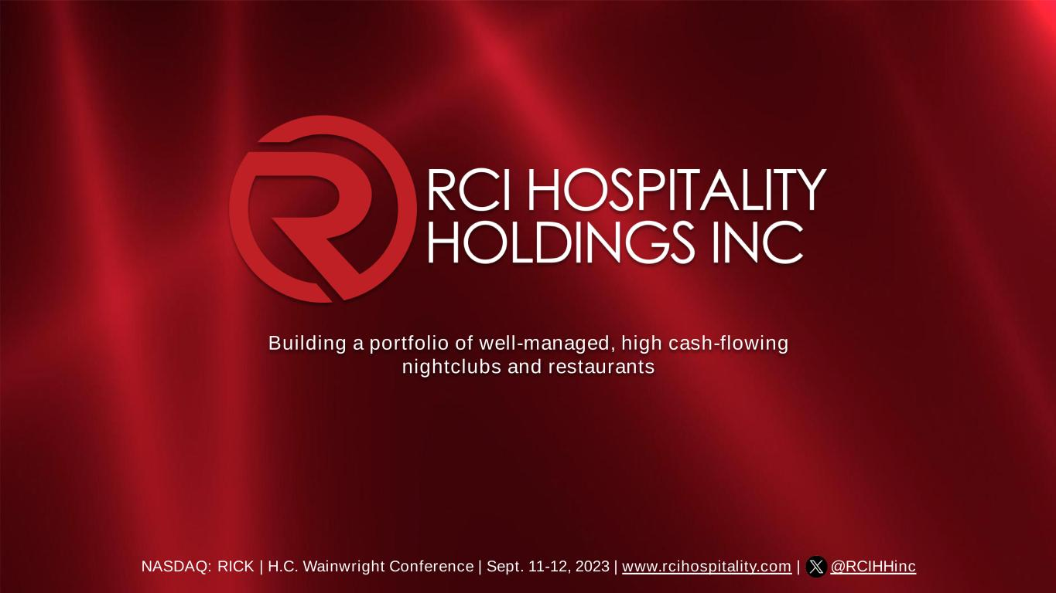
Building a portfolio of well-managed, high cash-flowing nightclubs and restaurants NASDAQ: RICK | H.C. Wainwright Conference | Sept. 11-12, 2023 | www.rcihospitality.com | @RCIHHinc

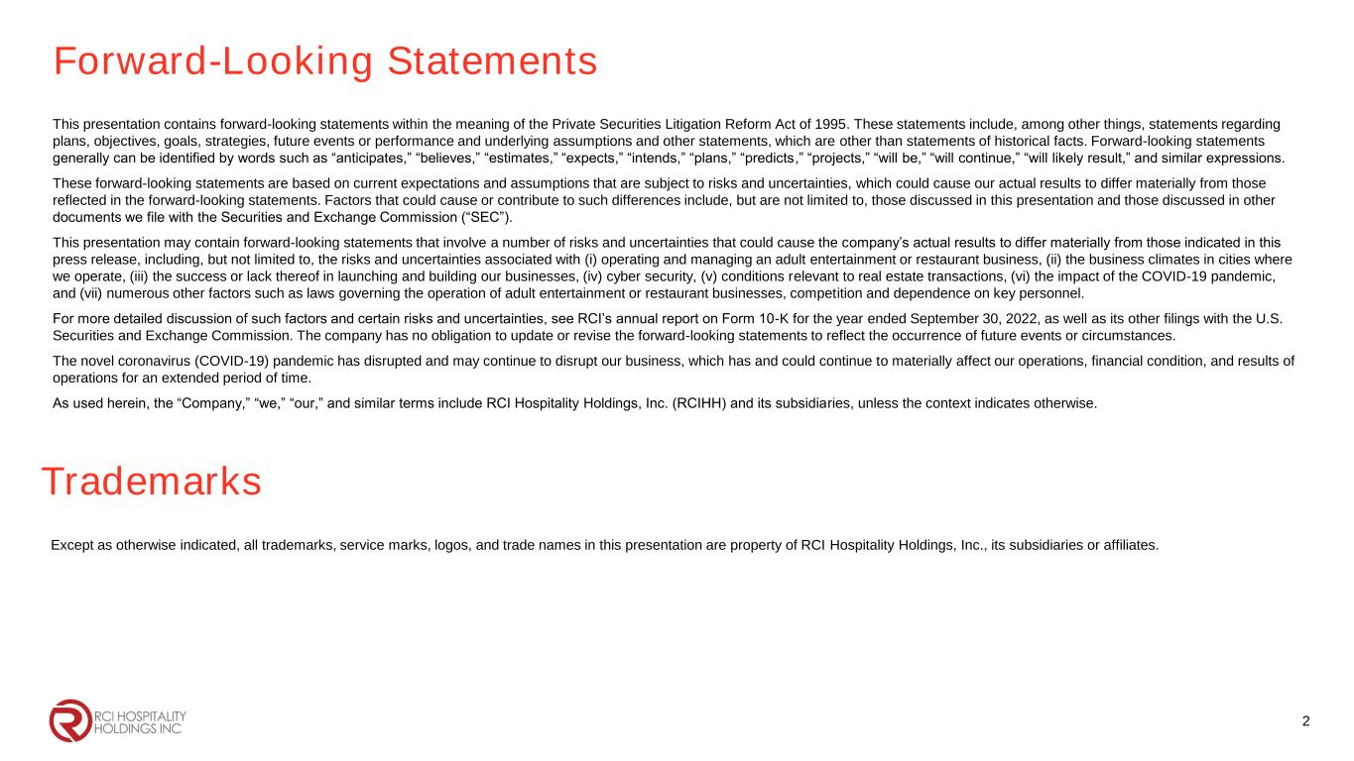
Forward-Looking Statements This presentation contains forward-looking statements within the meaning of the Private Securities Litigation Reform Act of 1995. These statements include, among other things, statements regarding plans, objectives, goals, strategies, future events or performance and underlying assumptions and other statements, which are other than statements of historical facts. Forward-looking statements generally can be identified by words such as “anticipates,” “believes,” “estimates,” “expects,” “intends,” “plans,” “predicts,” “projects,” “will be,” “will continue,” “will likely result,” and similar expressions. These forward-looking statements are based on current expectations and assumptions that are subject to risks and uncertainties, which could cause our actual results to differ materially from those reflected in the forward-looking statements. Factors that could cause or contribute to such differences include, but are not limited to, those discussed in this presentation and those discussed in other documents we file with the Securities and Exchange Commission (“SEC”). This presentation may contain forward-looking statements that involve a number of risks and uncertainties that could cause the company’s actual results to differ materially from those indicated in this press release, including, but not limited to, the risks and uncertainties associated with (i) operating and managing an adult entertainment or restaurant business, (ii) the business climates in cities where we operate, (iii) the success or lack thereof in launching and building our businesses, (iv) cyber security, (v) conditions relevant to real estate transactions, (vi) the impact of the COVID-19 pandemic, and (vii) numerous other factors such as laws governing the operation of adult entertainment or restaurant businesses, competition and dependence on key personnel. For more detailed discussion of such factors and certain risks and uncertainties, see RCI’s annual report on Form 10-K for the year ended September 30, 2022, as well as its other filings with the U.S. Securities and Exchange Commission. The company has no obligation to update or revise the forward-looking statements to reflect the occurrence of future events or circumstances. The novel coronavirus (COVID-19) pandemic has disrupted and may continue to disrupt our business, which has and could continue to materially affect our operations, financial condition, and results of operations for an extended period of time. As used herein, the “Company,” “we,” “our,” and similar terms include RCI Hospitality Holdings, Inc. (RCIHH) and its subsidiaries, unless the context indicates otherwise. 2 Trademarks Except as otherwise indicated, all trademarks, service marks, logos, and trade names in this presentation are property of RCI Hospitality Holdings, Inc., its subsidiaries or affiliates.

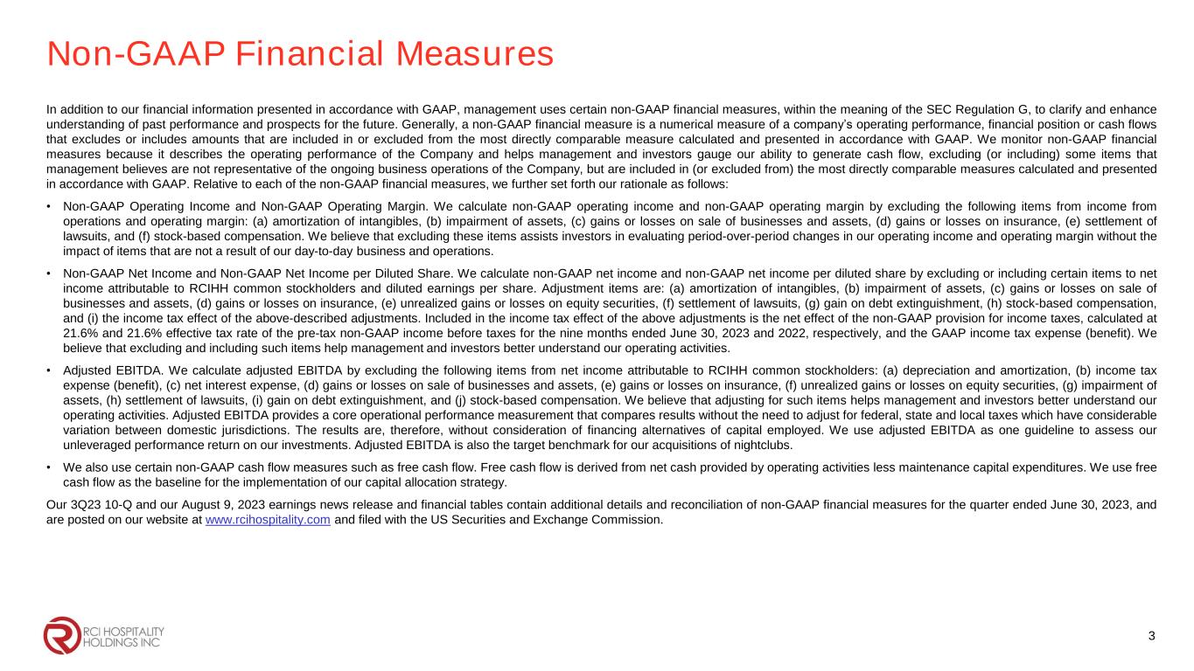
Non-GAAP Financial Measures In addition to our financial information presented in accordance with GAAP, management uses certain non-GAAP financial measures, within the meaning of the SEC Regulation G, to clarify and enhance understanding of past performance and prospects for the future. Generally, a non-GAAP financial measure is a numerical measure of a company’s operating performance, financial position or cash flows that excludes or includes amounts that are included in or excluded from the most directly comparable measure calculated and presented in accordance with GAAP. We monitor non-GAAP financial measures because it describes the operating performance of the Company and helps management and investors gauge our ability to generate cash flow, excluding (or including) some items that management believes are not representative of the ongoing business operations of the Company, but are included in (or excluded from) the most directly comparable measures calculated and presented in accordance with GAAP. Relative to each of the non-GAAP financial measures, we further set forth our rationale as follows: • Non-GAAP Operating Income and Non-GAAP Operating Margin. We calculate non-GAAP operating income and non-GAAP operating margin by excluding the following items from income from operations and operating margin: (a) amortization of intangibles, (b) impairment of assets, (c) gains or losses on sale of businesses and assets, (d) gains or losses on insurance, (e) settlement of lawsuits, and (f) stock-based compensation. We believe that excluding these items assists investors in evaluating period-over-period changes in our operating income and operating margin without the impact of items that are not a result of our day-to-day business and operations. • Non-GAAP Net Income and Non-GAAP Net Income per Diluted Share. We calculate non-GAAP net income and non-GAAP net income per diluted share by excluding or including certain items to net income attributable to RCIHH common stockholders and diluted earnings per share. Adjustment items are: (a) amortization of intangibles, (b) impairment of assets, (c) gains or losses on sale of businesses and assets, (d) gains or losses on insurance, (e) unrealized gains or losses on equity securities, (f) settlement of lawsuits, (g) gain on debt extinguishment, (h) stock-based compensation, and (i) the income tax effect of the above-described adjustments. Included in the income tax effect of the above adjustments is the net effect of the non-GAAP provision for income taxes, calculated at 21.6% and 21.6% effective tax rate of the pre-tax non-GAAP income before taxes for the nine months ended June 30, 2023 and 2022, respectively, and the GAAP income tax expense (benefit). We believe that excluding and including such items help management and investors better understand our operating activities. • Adjusted EBITDA. We calculate adjusted EBITDA by excluding the following items from net income attributable to RCIHH common stockholders: (a) depreciation and amortization, (b) income tax expense (benefit), (c) net interest expense, (d) gains or losses on sale of businesses and assets, (e) gains or losses on insurance, (f) unrealized gains or losses on equity securities, (g) impairment of assets, (h) settlement of lawsuits, (i) gain on debt extinguishment, and (j) stock-based compensation. We believe that adjusting for such items helps management and investors better understand our operating activities. Adjusted EBITDA provides a core operational performance measurement that compares results without the need to adjust for federal, state and local taxes which have considerable variation between domestic jurisdictions. The results are, therefore, without consideration of financing alternatives of capital employed. We use adjusted EBITDA as one guideline to assess our unleveraged performance return on our investments. Adjusted EBITDA is also the target benchmark for our acquisitions of nightclubs. • We also use certain non-GAAP cash flow measures such as free cash flow. Free cash flow is derived from net cash provided by operating activities less maintenance capital expenditures. We use free cash flow as the baseline for the implementation of our capital allocation strategy. Our 3Q23 10-Q and our August 9, 2023 earnings news release and financial tables contain additional details and reconciliation of non-GAAP financial measures for the quarter ended June 30, 2023, and are posted on our website at www.rcihospitality.com and filed with the US Securities and Exchange Commission. 3

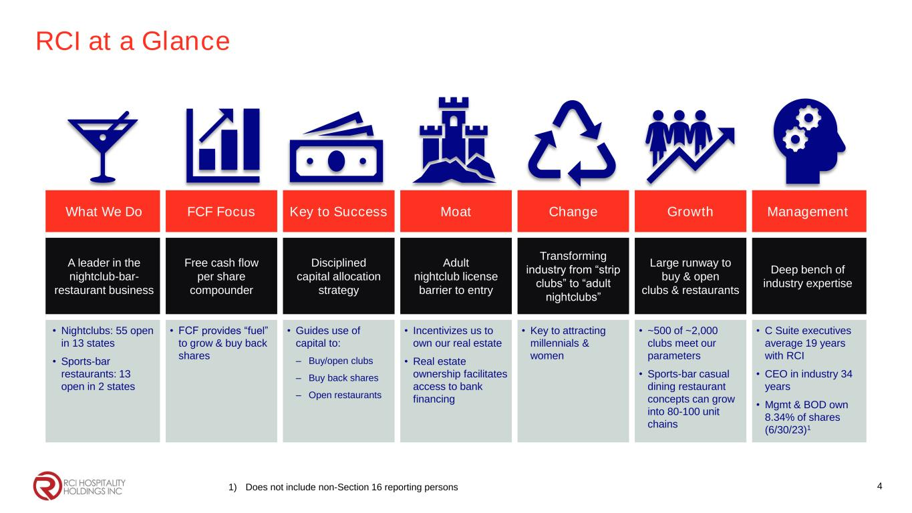
RCI at a Glance What We Do FCF Focus Key to Success Moat Change Growth Management A leader in the nightclub-bar- restaurant business Free cash flow per share compounder Disciplined capital allocation strategy Adult nightclub license barrier to entry Transforming industry from “strip clubs” to “adult nightclubs” Large runway to buy & open clubs & restaurants Deep bench of industry expertise • Nightclubs: 55 open in 13 states • Sports-bar restaurants: 13 open in 2 states • FCF provides “fuel” to grow & buy back shares • Guides use of capital to: – Buy/open clubs – Buy back shares – Open restaurants • Incentivizes us to own our real estate • Real estate ownership facilitates access to bank financing • Key to attracting millennials & women • ~500 of ~2,000 clubs meet our parameters • Sports-bar casual dining restaurant concepts can grow into 80-100 unit chains • C Suite executives average 19 years with RCI • CEO in industry 34 years • Mgmt & BOD own 8.34% of shares (6/30/23)1 41) Does not include non-Section 16 reporting persons

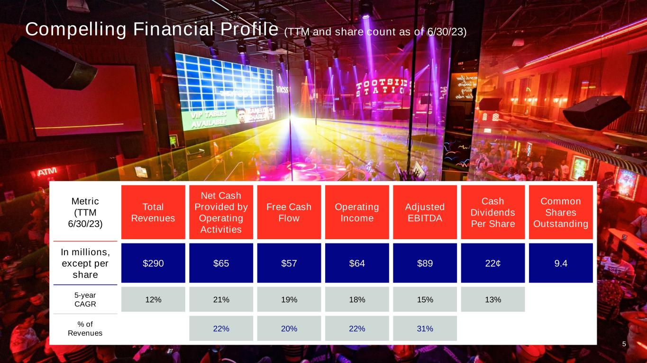
Compelling Financial Profile (TTM and share count as of 6/30/23) Metric (TTM 6/30/23) Total Revenues Net Cash Provided by Operating Activities Free Cash Flow Operating Income Adjusted EBITDA Cash Dividends Per Share Common Shares Outstanding In millions, except per share $290 $65 $57 $64 $89 22¢ 9.4 5-year CAGR 12% 21% 19% 18% 15% 13% % of Revenues 22% 20% 22% 31% 5

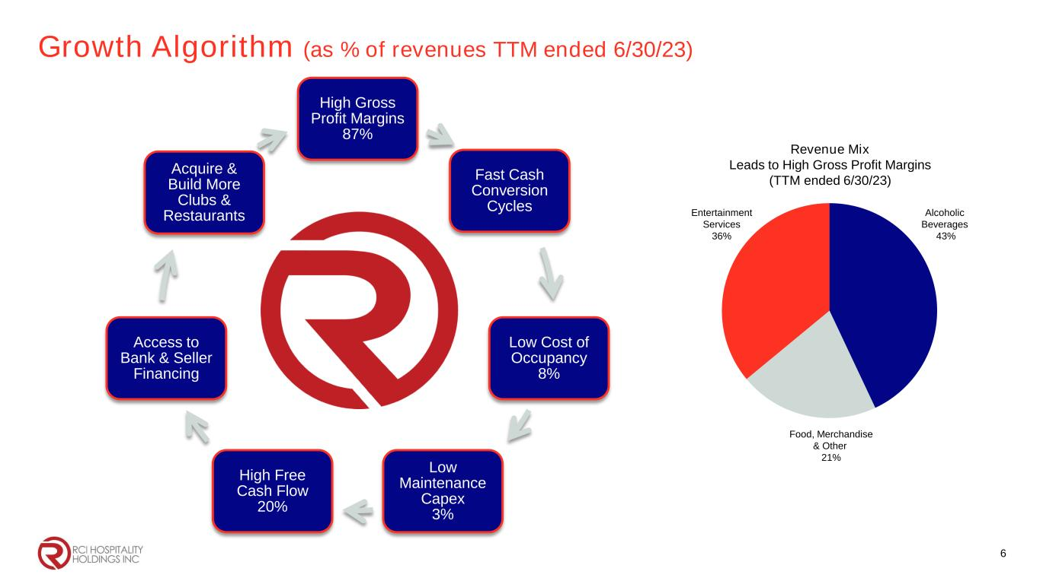
Growth Algorithm (as % of revenues TTM ended 6/30/23) High Gross Profit Margins 87% Fast Cash Conversion Cycles Low Cost of Occupancy 8% Low Maintenance Capex 3% High Free Cash Flow 20% Access to Bank & Seller Financing Acquire & Build More Clubs & Restaurants Revenue Mix Leads to High Gross Profit Margins (TTM ended 6/30/23) Alcoholic Beverages 43% Entertainment Services 36% Food, Merchandise & Other 21% 6

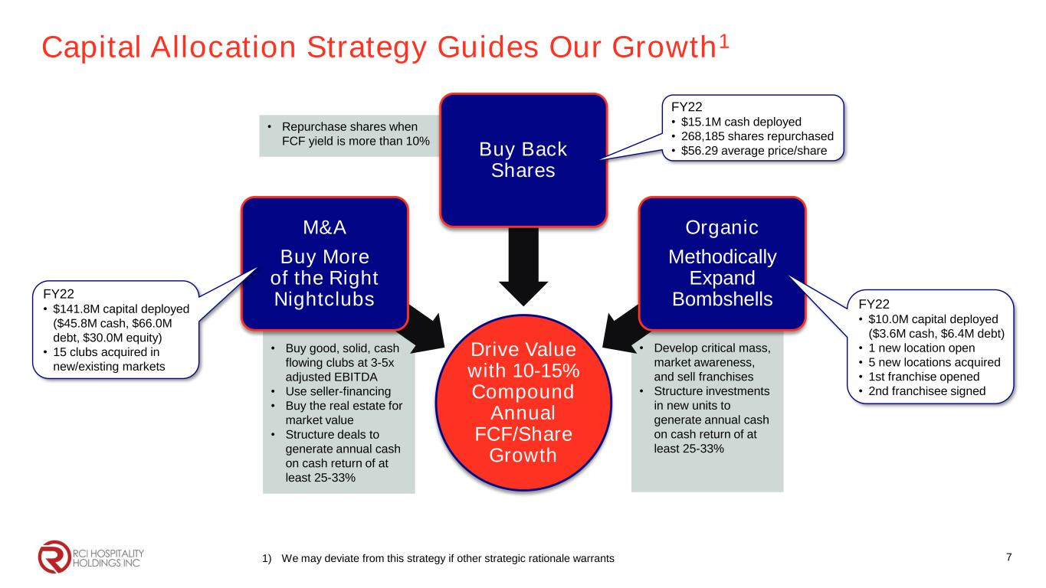
Capital Allocation Strategy Guides Our Growth1 1) We may deviate from this strategy if other strategic rationale warrants • Repurchase shares when FCF yield is more than 10% • Develop critical mass, market awareness, and sell franchises • Structure investments in new units to generate annual cash on cash return of at least 25-33% • Buy good, solid, cash flowing clubs at 3-5x adjusted EBITDA • Use seller-financing • Buy the real estate for market value • Structure deals to generate annual cash on cash return of at least 25-33% Drive Value with 10-15% Compound Annual FCF/Share Growth M&A Buy More of the Right Nightclubs Buy Back Shares Organic Methodically Expand Bombshells 7 FY22 • $15.1M cash deployed • 268,185 shares repurchased • $56.29 average price/share FY22 • $10.0M capital deployed ($3.6M cash, $6.4M debt) • 1 new location open • 5 new locations acquired • 1st franchise opened • 2nd franchisee signed FY22 • $141.8M capital deployed ($45.8M cash, $66.0M debt, $30.0M equity) • 15 clubs acquired in new/existing markets

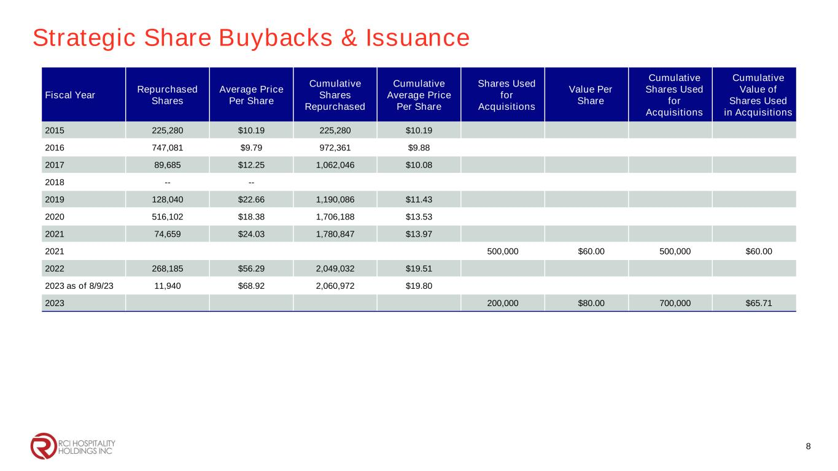
Strategic Share Buybacks & Issuance Fiscal Year Repurchased Shares Average Price Per Share Cumulative Shares Repurchased Cumulative Average Price Per Share Shares Used for Acquisitions Value Per Share Cumulative Shares Used for Acquisitions Cumulative Value of Shares Used in Acquisitions 2015 225,280 $10.19 225,280 $10.19 2016 747,081 $9.79 972,361 $9.88 2017 89,685 $12.25 1,062,046 $10.08 2018 -- -- 2019 128,040 $22.66 1,190,086 $11.43 2020 516,102 $18.38 1,706,188 $13.53 2021 74,659 $24.03 1,780,847 $13.97 2021 500,000 $60.00 500,000 $60.00 2022 268,185 $56.29 2,049,032 $19.51 2023 as of 8/9/23 11,940 $68.92 2,060,972 $19.80 2023 200,000 $80.00 700,000 $65.71 8

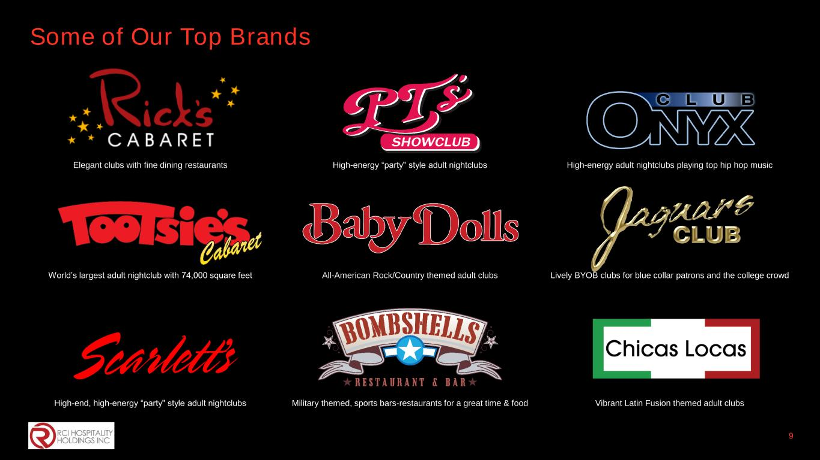
Some of Our Top Brands 9 Elegant clubs with fine dining restaurants High-energy “party" style adult nightclubs High-energy adult nightclubs playing top hip hop music World’s largest adult nightclub with 74,000 square feet All-American Rock/Country themed adult clubs Lively BYOB clubs for blue collar patrons and the college crowd High-end, high-energy “party" style adult nightclubs Military themed, sports bars-restaurants for a great time & food Vibrant Latin Fusion themed adult clubs

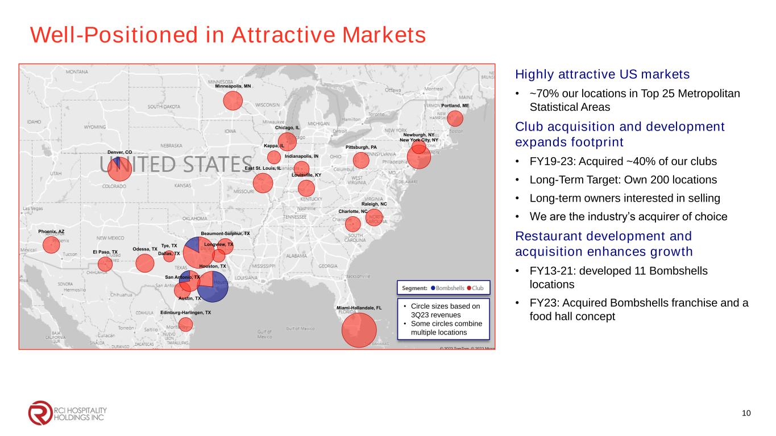
Well-Positioned in Attractive Markets 10 Highly attractive US markets • ~70% our locations in Top 25 Metropolitan Statistical Areas Club acquisition and development expands footprint • FY19-23: Acquired ~40% of our clubs • Long-Term Target: Own 200 locations • Long-term owners interested in selling • We are the industry’s acquirer of choice Restaurant development and acquisition enhances growth • FY13-21: developed 11 Bombshells locations • FY23: Acquired Bombshells franchise and a food hall concept 0 om om, 0 icrosoft Corporation , i ft ti • Circle sizes based on 3Q23 revenues • Some circles combine multiple locations

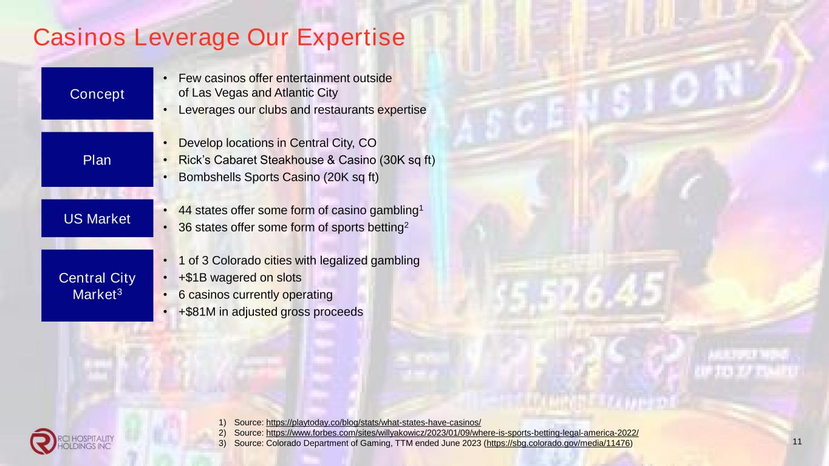
Casinos Leverage Our Expertise Concept • Few casinos offer entertainment outside of Las Vegas and Atlantic City • Leverages our clubs and restaurants expertise Plan • Develop locations in Central City, CO • Rick’s Cabaret Steakhouse & Casino ( 0K sq ft) • Bombshells Sports Casino (20K sq ft) US Market • 44 states offer some form of casino gambling1 • 36 states offer some form of sports betting2 Central City Market3 • 1 of 3 Colorado cities with legalized gambling • +$1B wagered on slots • 6 casinos currently operating • +$81M in adjusted gross proceeds 11 1) Source: https://playtoday.co/blog/stats/what-states-have-casinos/ 2) Source: https://www.forbes.com/sites/willyakowicz/2023/01/09/where-is-sports-betting-legal-america-2022/ 3) Source: Colorado Department of Gaming, TTM ended June 2023 (https://sbg.colorado.gov/media/11476)

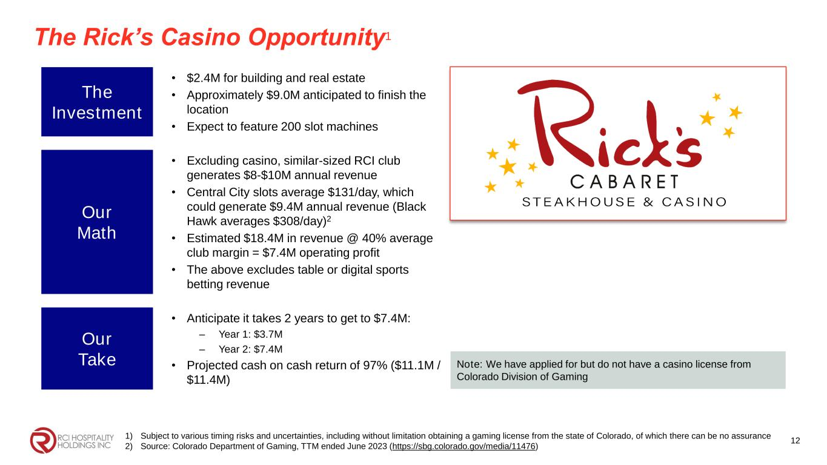
The Rick’s Casino Opportunity1 The Investment • $2.4M for building and real estate • Approximately $9.0M anticipated to finish the location • Expect to feature 200 slot machines Our Math • Excluding casino, similar-sized RCI club generates $8-$10M annual revenue • Central City slots average $131/day, which could generate $9.4M annual revenue (Black Hawk averages $308/day)2 • Estimated $18.4M in revenue @ 40% average club margin = $7.4M operating profit • The above excludes table or digital sports betting revenue Our Take • Anticipate it takes 2 years to get to $7.4M: – Year 1: $3.7M – Year 2: $7.4M • Projected cash on cash return of 97% ($11.1M / $11.4M) 12 Note: We have applied for but do not have a casino license from Colorado Division of Gaming 1) Subject to various timing risks and uncertainties, including without limitation obtaining a gaming license from the state of Colorado, of which there can be no assurance 2) Source: Colorado Department of Gaming, TTM ended June 2023 (https://sbg.colorado.gov/media/11476)

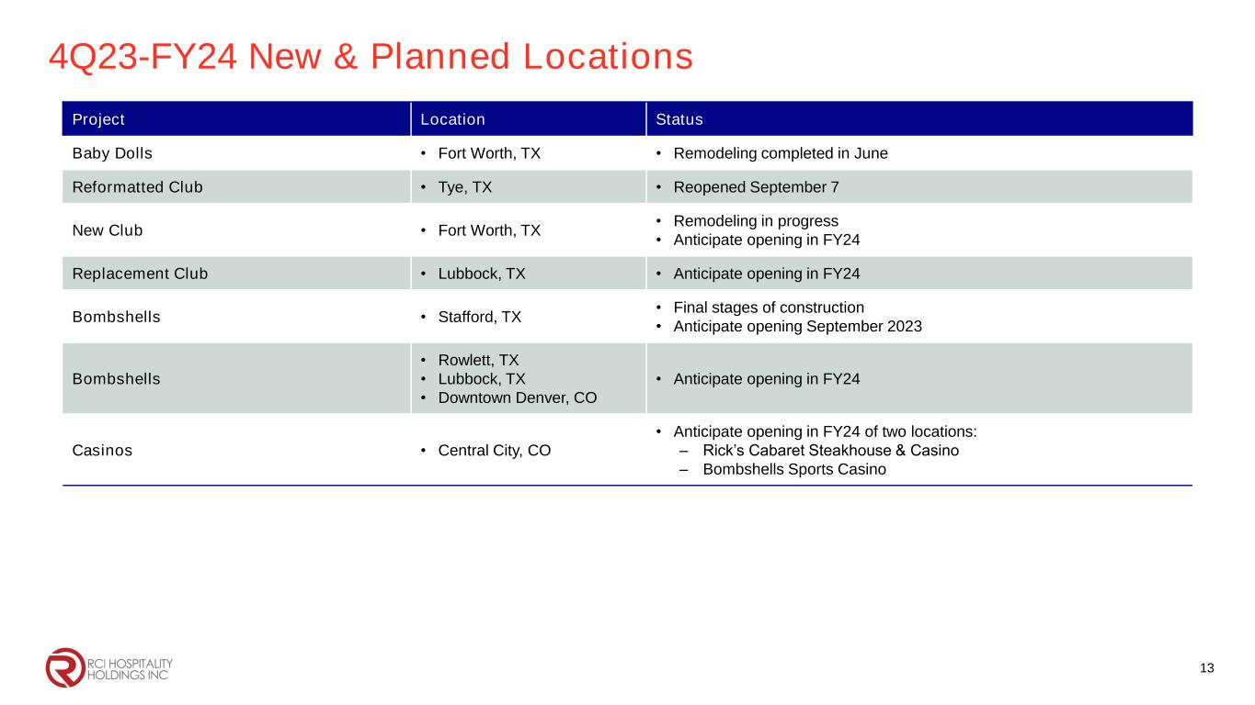
4Q23-FY24 New & Planned Locations Project Location Status Baby Dolls • Fort Worth, TX • Remodeling completed in June Reformatted Club • Tye, TX • Reopened September 7 New Club • Fort Worth, TX • Remodeling in progress • Anticipate opening in FY24 Replacement Club • Lubbock, TX • Anticipate opening in FY24 Bombshells • Stafford, TX • Final stages of construction • Anticipate opening September 2023 Bombshells • Rowlett, TX • Lubbock, TX • Downtown Denver, CO • Anticipate opening in FY24 Casinos • Central City, CO • Anticipate opening in FY24 of two locations: – Rick’s Cabaret Steakhouse & Casino – Bombshells Sports Casino 13


Corporate Office 10737 Cutten Road Houston, TX 77066 Phone: (281) 397-6730 Investor Relations Gary Fishman Steven Anreder Phone: (212) 532-3232 IR Website www.rcihospitality.com Nasdaq: RICK Contact Information 14

