United States
Securities and Exchange Commission
Washington, D.C. 20549
FORM 8-K
Current Report
Pursuant to Section 13 or 15(d) of
The Securities Exchange Act of 1934
Date of Report (Date of earliest event reported): April 20, 2022
RCI HOSPITALITY HOLDINGS, INC.
(Exact Name of Registrant as Specified in Its Charter)

Texas |  |  | 001-13992 |  |  | 76-0458229
(State or Other Jurisdiction  of Incorporation) |  |  | (Commission  File Number) |  |  | (IRS Employer  Identification No.)
10737 Cutten Road
Houston, Texas 77066
(Address of Principal Executive Offices, Including Zip Code)
(281) 397-6730
(Issuer’s Telephone Number, Including Area Code)
Check the appropriate box below if the Form 8-K filing is intended to simultaneously satisfy the filing obligation of the registrant under any of the following provisions:

o |  |  | Written communications pursuant to Rule 425 under the Securities Act (17 CFR 230.425)
o |  |  | Soliciting material pursuant to Rule 14a-12 under the Exchange Act (17 CFR 240.14a -12)
o |  |  | Pre-commencement communications pursuant to Rule 14d-2(b) under the Exchange Act (17 CFR 240.14d -2(b))
o |  |  | Pre-commencement communications pursuant to Rule 13e-4(c) under the Exchange Act (17 CFR 240.13e -4(c))
Securities registered pursuant to Section 12(b) of the Act:

Title of each class |  |  |  |  |  | Trading Symbol(s) |  |  |  |  |  | Name of each exchange on which registered
Common stock, $0.01 par value |  |  |  |  |  | RICK |  |  |  |  |  | The Nasdaq Global Market
Indicate by check mark whether the registrant is an emerging growth company as defined in Rule 405 of the Securities Act of 1933 (§230.405 of this chapter) or Rule 12b-2 of the Securities Exchange Act of 1934 (§240.12b-2 of this chapter).
Emerging growth company o
If an emerging growth company, indicate by check mark if the registrant has elected not to use the extended transition period for complying with any new or revised financial accounting standards provided pursuant to Section 13(a) of the Exchange Act. o

ITEM 2.02 RESULTS OF OPERATIONS AND FINANCIAL CONDITION.

On April 20 and 21, 2022, we will be presenting at Noble Capital Markets’ 18th Annual Investor Conference. On April 14, 2020, we issued a press release announcing this. A copy of the press release is furnished as Exhibit 99.1 to this current report on Form 8-K, and a copy of the presentation slides is furnished with this current report as Exhibit 99.2. The presentation slides may be used in whole or in part in meetings with investors and analysts beginning on April 20, 2022.

ITEM 7.01 REGULATION FD DISCLOSURE

The disclosure in Item 2.02 above is incorporated herein by reference.

The furnishing of the attached presentation slides is not an admission as to the materiality of any information therein. The information contained in the slides is summary information that is intended to be considered in the context of more complete information included in our filings with the U.S. Securities and Exchange Commission (the “SEC”) and other public announcements that we have made and may make from time to time by press release or otherwise. We undertake no duty or obligation to update or revise the information contained in this report, although we may do so from time to time as management believes is appropriate. Any such updating may be made through the filing of other reports or documents with the SEC, through press releases or through other public disclosures. For important information about forward looking statements, see the slide titled “Forward-Looking Statements” in Exhibit 99.2 included herewith.

The information in this current report on Form 8-K, including Exhibit 99.1 and Exhibit 99.2, is being furnished and will not be treated as “filed” for the purposes of Section 18 of the Securities Exchange Act of 1934, as amended, or otherwise subject to the liabilities of that section.

ITEM 9.01 FINANCIAL STATEMENTS AND EXHIBITS
(d)Exhibits

Exhibit Number |  |  |  |  |  | Description
99.1 |  |  |  |  |  | Press release of RCI Hospitality Holdings, Inc. dated April 14, 2022
99.2 |  |  |  |  |  | Presentation Slides - Investor Presentation
2

SIGNATURES
Pursuant to the requirements of the Securities Exchange Act of 1934, the registrant has duly caused this report to be signed on its behalf by the undersigned hereunto duly authorized.

 |  |  | RCI HOSPITALITY HOLDINGS, INC.
Date: April 20, 2022 |  |  | By: |  |  | /s/ Eric Langan
 |  |  |  |  |  | Eric Langan
 |  |  |  |  |  | President and Chief Executive Officer
3


RCI to Participate in Noble Capital Markets Conference on April 20-21, 2022
HOUSTON—April 14, 2022—RCI Hospitality Holdings, Inc. (Nasdaq: RICK) today announced CEO Eric Langan and CFO Bradley Chhay will present and meet investors at Noble Capital Markets’ 18th Annual Investor Conference on Wednesday and Thursday, April 20 and 21, at the Hard Rock Hotel & Casino, Hollywood, FL.
RCI’s presentation is scheduled for April 20 at 2 PM ET. A PDF of the presentation will be available at this link. A high-definition, video webcast will be available the next day at this link. The webcast will be archived for 90 days.
Investors can also meet management at breakout sessions scheduled for April 20 at 11:30 AM ET at Table 1 and April 21 at 10 AM ET at Table 3 and 1:45 PM ET at Table 7.
Investor registration to attend the conference is free. Visit https://www.nobleconference.com/eighteen.
About Noble Capital Markets, Inc. www.noblecapitalmarkets.com
Noble Capital Markets is a research driven investment bank that has supported small & microcap companies since 1984. As a FINRA and SEC licensed broker dealer Noble provides institutional-quality equity research, merchant and investment banking, and order execution services. In 2005, Noble established NobleCon, an investor conference that has grown substantially over the last decade.
About RCI Hospitality Holdings, Inc. (Nasdaq: RICK) www.rcihospitality.com
With more than 50 units, RCI Hospitality Holdings, Inc., through its subsidiaries, is the country’s leading company in gentlemen’s clubs and sports bars/restaurants. Clubs in New York City, Chicago, Dallas-Fort Worth, Houston, Miami, Minneapolis, Denver, St. Louis, Charlotte, Pittsburgh, Raleigh, Louisville, and other markets operate under brand names such as Rick's Cabaret, XTC, Club Onyx, Vivid Cabaret, Jaguars Club, Tootsie’s Cabaret, and Scarlett’s Cabaret. Sports bars/restaurants operate under the brand name Bombshells Restaurant & Bar.
Media and Investor Contacts
Gary Fishman and Steven Anreder at 212-532-3232 or gary.fishman@anreder.com and steven.anreder@anreder.com

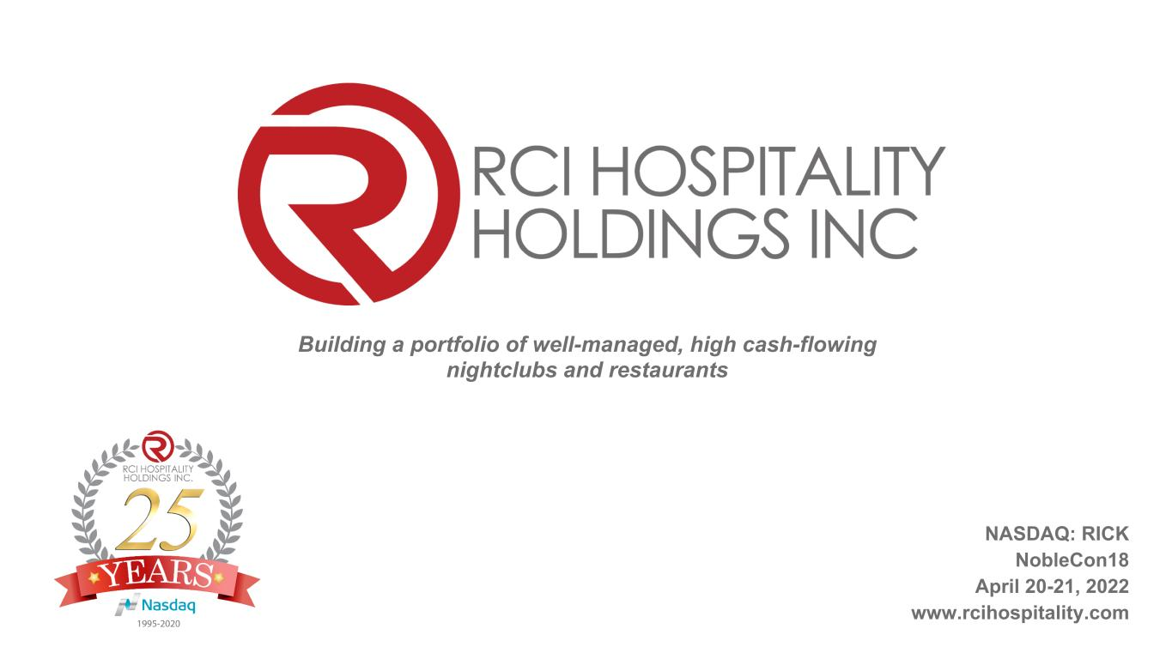
Building a portfolio of well-managed, high cash-flowing nightclubs and restaurants NASDAQ: RICK NobleCon18 April 20-21, 2022 www.rcihospitality.com

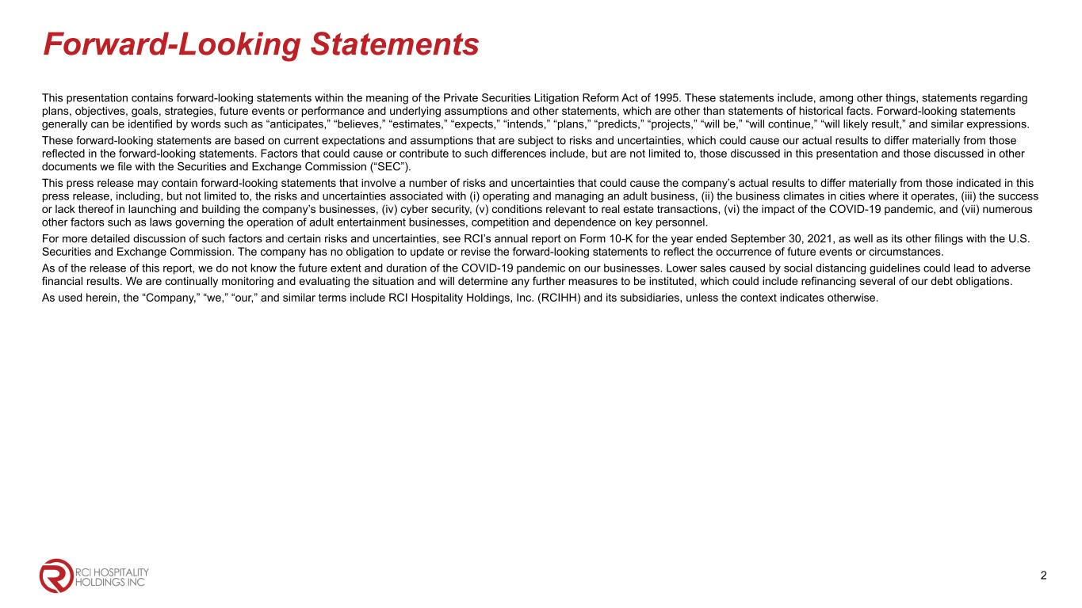
Forward-Looking Statements This presentation contains forward-looking statements within the meaning of the Private Securities Litigation Reform Act of 1995. These statements include, among other things, statements regarding plans, objectives, goals, strategies, future events or performance and underlying assumptions and other statements, which are other than statements of historical facts. Forward-looking statements generally can be identified by words such as “anticipates,” “believes,” “estimates,” “expects,” “intends,” “plans,” “predicts,” “projects,” “will be,” “will continue,” “will likely result,” and similar expressions. These forward-looking statements are based on current expectations and assumptions that are subject to risks and uncertainties, which could cause our actual results to differ materially from those reflected in the forward-looking statements. Factors that could cause or contribute to such differences include, but are not limited to, those discussed in this presentation and those discussed in other documents we file with the Securities and Exchange Commission (“SEC”). This press release may contain forward-looking statements that involve a number of risks and uncertainties that could cause the company’s actual results to differ materially from those indicated in this press release, including, but not limited to, the risks and uncertainties associated with (i) operating and managing an adult business, (ii) the business climates in cities where it operates, (iii) the success or lack thereof in launching and building the company’s businesses, (iv) cyber security, (v) conditions relevant to real estate transactions, (vi) the impact of the COVID-19 pandemic, and (vii) numerous other factors such as laws governing the operation of adult entertainment businesses, competition and dependence on key personnel. For more detailed discussion of such factors and certain risks and uncertainties, see RCI’s annual report on Form 10-K for the year ended September 30, 2021, as well as its other filings with the U.S. Securities and Exchange Commission. The company has no obligation to update or revise the forward-looking statements to reflect the occurrence of future events or circumstances. As of the release of this report, we do not know the future extent and duration of the COVID-19 pandemic on our businesses. Lower sales caused by social distancing guidelines could lead to adverse financial results. We are continually monitoring and evaluating the situation and will determine any further measures to be instituted, which could include refinancing several of our debt obligations. As used herein, the “Company,” “we,” “our,” and similar terms include RCI Hospitality Holdings, Inc. (RCIHH) and its subsidiaries, unless the context indicates otherwise. 2

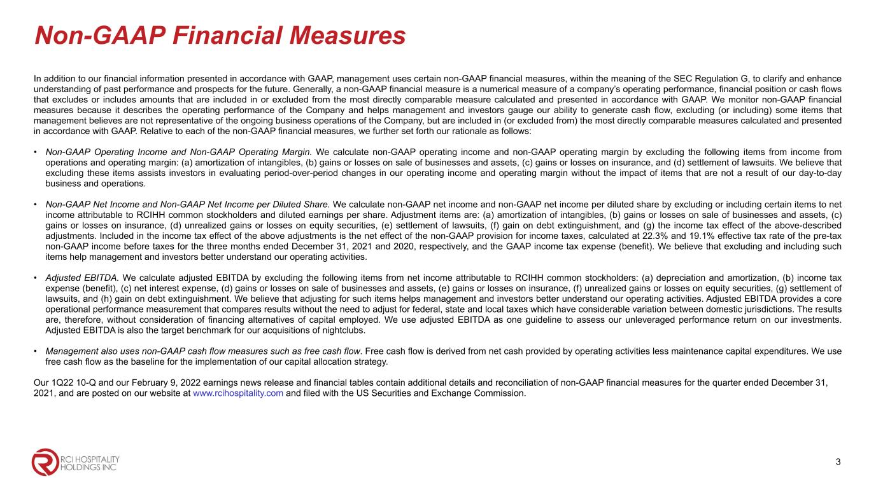
Non-GAAP Financial Measures In addition to our financial information presented in accordance with GAAP, management uses certain non-GAAP financial measures, within the meaning of the SEC Regulation G, to clarify and enhance understanding of past performance and prospects for the future. Generally, a non-GAAP financial measure is a numerical measure of a company’s operating performance, financial position or cash flows that excludes or includes amounts that are included in or excluded from the most directly comparable measure calculated and presented in accordance with GAAP. We monitor non-GAAP financial measures because it describes the operating performance of the Company and helps management and investors gauge our ability to generate cash flow, excluding (or including) some items that management believes are not representative of the ongoing business operations of the Company, but are included in (or excluded from) the most directly comparable measures calculated and presented in accordance with GAAP. Relative to each of the non-GAAP financial measures, we further set forth our rationale as follows: • Non-GAAP Operating Income and Non-GAAP Operating Margin. We calculate non-GAAP operating income and non-GAAP operating margin by excluding the following items from income from operations and operating margin: (a) amortization of intangibles, (b) gains or losses on sale of businesses and assets, (c) gains or losses on insurance, and (d) settlement of lawsuits. We believe that excluding these items assists investors in evaluating period-over-period changes in our operating income and operating margin without the impact of items that are not a result of our day-to-day business and operations. • Non-GAAP Net Income and Non-GAAP Net Income per Diluted Share. We calculate non-GAAP net income and non-GAAP net income per diluted share by excluding or including certain items to net income attributable to RCIHH common stockholders and diluted earnings per share. Adjustment items are: (a) amortization of intangibles, (b) gains or losses on sale of businesses and assets, (c) gains or losses on insurance, (d) unrealized gains or losses on equity securities, (e) settlement of lawsuits, (f) gain on debt extinguishment, and (g) the income tax effect of the above-described adjustments. Included in the income tax effect of the above adjustments is the net effect of the non-GAAP provision for income taxes, calculated at 22.3% and 19.1% effective tax rate of the pre-tax non-GAAP income before taxes for the three months ended December 31, 2021 and 2020, respectively, and the GAAP income tax expense (benefit). We believe that excluding and including such items help management and investors better understand our operating activities. • Adjusted EBITDA. We calculate adjusted EBITDA by excluding the following items from net income attributable to RCIHH common stockholders: (a) depreciation and amortization, (b) income tax expense (benefit), (c) net interest expense, (d) gains or losses on sale of businesses and assets, (e) gains or losses on insurance, (f) unrealized gains or losses on equity securities, (g) settlement of lawsuits, and (h) gain on debt extinguishment. We believe that adjusting for such items helps management and investors better understand our operating activities. Adjusted EBITDA provides a core operational performance measurement that compares results without the need to adjust for federal, state and local taxes which have considerable variation between domestic jurisdictions. The results are, therefore, without consideration of financing alternatives of capital employed. We use adjusted EBITDA as one guideline to assess our unleveraged performance return on our investments. Adjusted EBITDA is also the target benchmark for our acquisitions of nightclubs. • Management also uses non-GAAP cash flow measures such as free cash flow. Free cash flow is derived from net cash provided by operating activities less maintenance capital expenditures. We use free cash flow as the baseline for the implementation of our capital allocation strategy. Our 1Q22 10-Q and our February 9, 2022 earnings news release and financial tables contain additional details and reconciliation of non-GAAP financial measures for the quarter ended December 31, 2021, and are posted on our website at www.rcihospitality.com and filed with the US Securities and Exchange Commission. 3

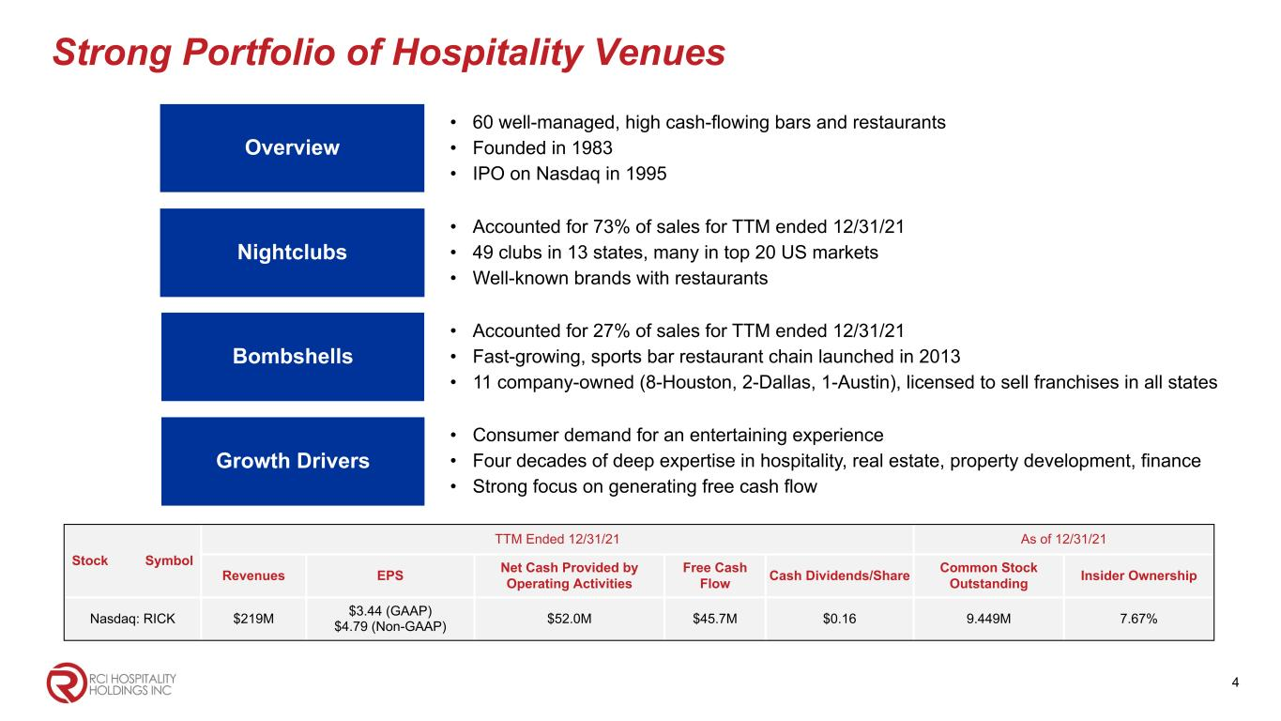
Strong Portfolio of Hospitality Venues Nightclubs • Accounted for 73% of sales for TTM ended 12/31/21 • 49 clubs in 13 states, many in top 20 US markets • Well-known brands with restaurants Overview • 60 well-managed, high cash-flowing bars and restaurants • Founded in 1983 • IPO on Nasdaq in 1995 Growth Drivers • Consumer demand for an entertaining experience • Four decades of deep expertise in hospitality, real estate, property development, finance • Strong focus on generating free cash flow Bombshells • Accounted for 27% of sales for TTM ended 12/31/21 • Fast-growing, sports bar restaurant chain launched in 2013 • 11 company-owned (8-Houston, 2-Dallas, 1-Austin), licensed to sell franchises in all states Stock Symbol TTM Ended 12/31/21 As of 12/31/21 Revenues EPS Net Cash Provided by Operating Activities Free Cash Flow Cash Dividends/Share Common Stock Outstanding Insider Ownership Nasdaq: RICK $219M $3.44 (GAAP) $4.79 (Non-GAAP) $52.0M $45.7M $0.16 9.449M 7.67% 4

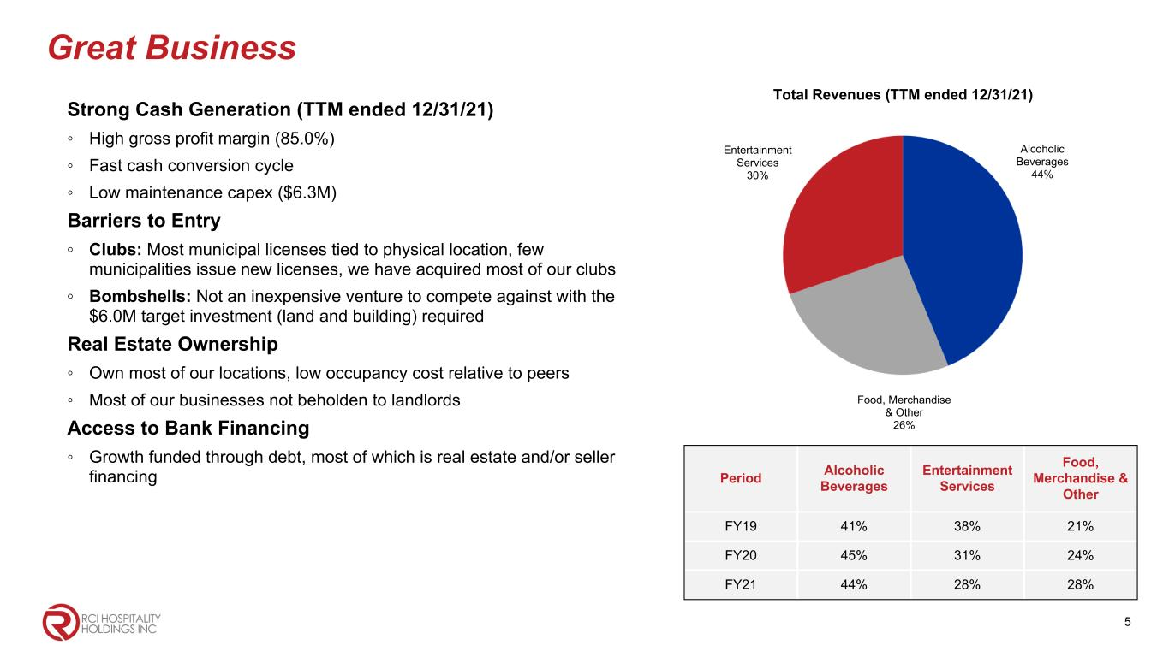
Great Business Strong Cash Generation (TTM ended 12/31/21) ◦ High gross profit margin (85.0%) ◦ Fast cash conversion cycle ◦ Low maintenance capex ($6.3M) Barriers to Entry ◦ Clubs: Most municipal licenses tied to physical location, few municipalities issue new licenses, we have acquired most of our clubs ◦ Bombshells: Not an inexpensive venture to compete against with the $6.0M target investment (land and building) required Real Estate Ownership ◦ Own most of our locations, low occupancy cost relative to peers ◦ Most of our businesses not beholden to landlords Access to Bank Financing ◦ Growth funded through debt, most of which is real estate and/or seller financing Total Revenues (TTM ended 12/31/21) Alcoholic Beverages 44% Entertainment Services 30% Food, Merchandise & Other 26% Period Alcoholic Beverages Entertainment Services Food, Merchandise & Other FY19 41% 38% 21% FY20 45% 31% 24% FY21 44% 28% 28% 5

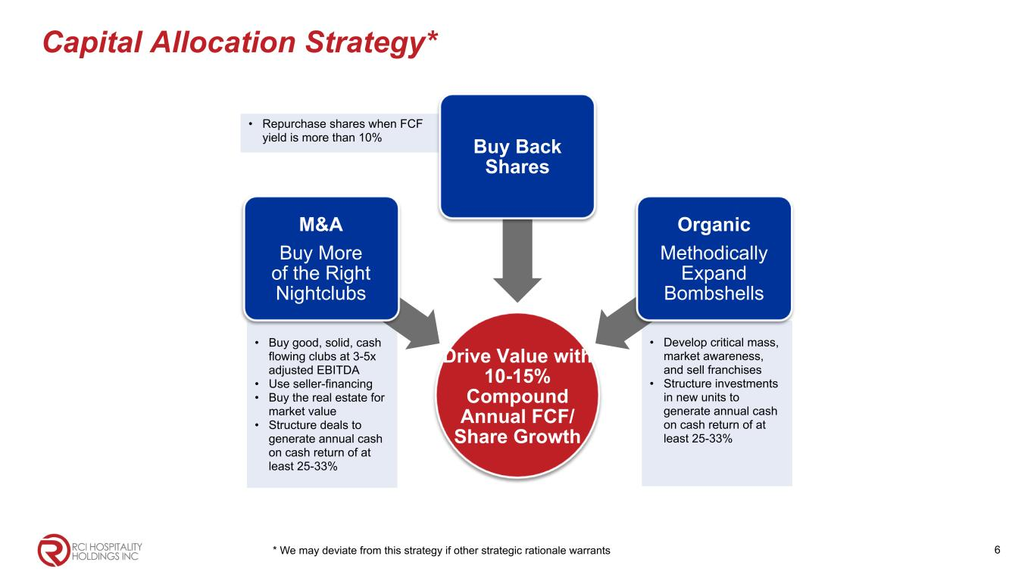
Capital Allocation Strategy* * We may deviate from this strategy if other strategic rationale warrants • Repurchase shares when FCF yield is more than 10% • Develop critical mass, market awareness, and sell franchises • Structure investments in new units to generate annual cash on cash return of at least 25-33% • Buy good, solid, cash flowing clubs at 3-5x adjusted EBITDA • Use seller-financing • Buy the real estate for market value • Structure deals to generate annual cash on cash return of at least 25-33% Drive Value with 10-15% Compound Annual FCF/ Share Growth M&A Buy More of the Right Nightclubs Buy Back Shares Organic Methodically Expand Bombshells 6

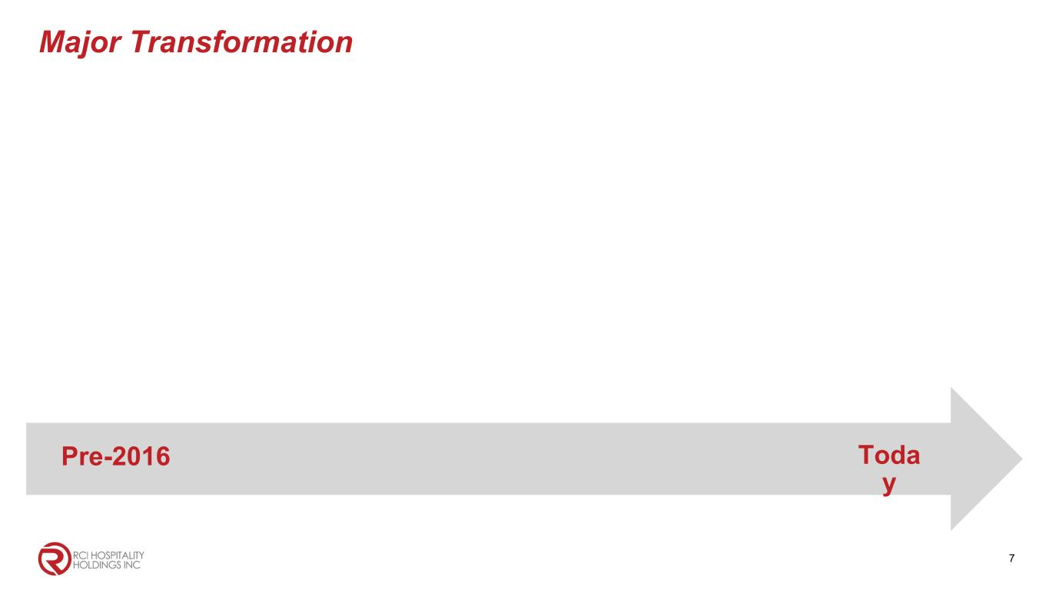
Major Transformation 7 Pre-2016 Toda y

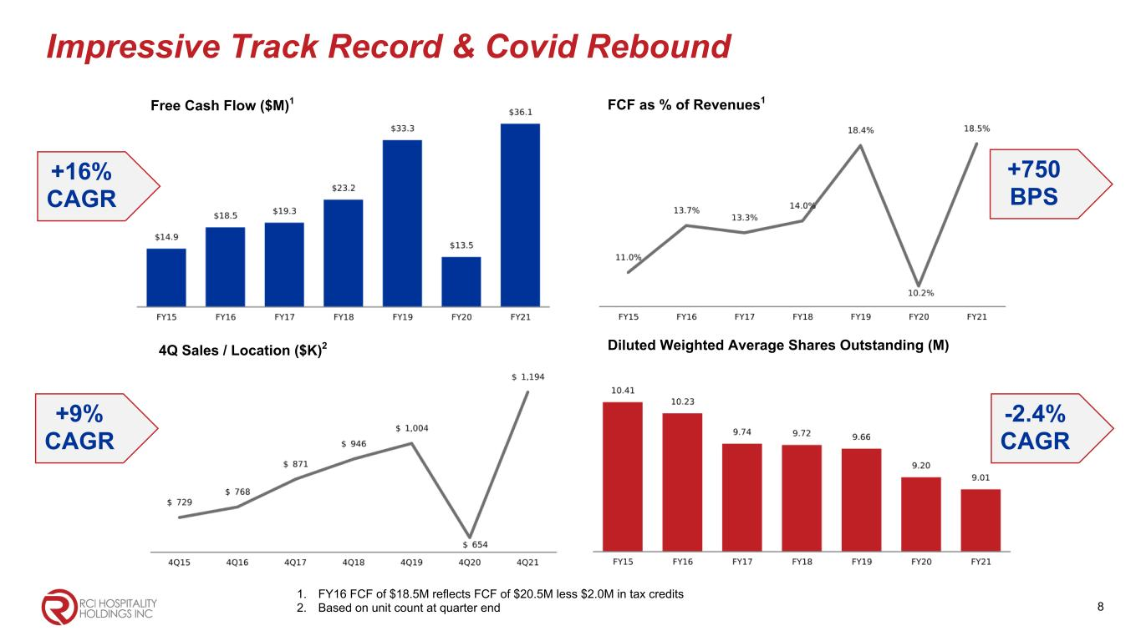
Impressive Track Record & Covid Rebound Free Cash Flow ($M)1 FCF as % of Revenues1 Diluted Weighted Average Shares Outstanding (M) 1. FY16 FCF of $18.5M reflects FCF of $20.5M less $2.0M in tax credits 2. Based on unit count at quarter end 4Q Sales / Location ($K)2 8 +16% CAGR +9% CAGR +750 BPS -2.4% CAGR

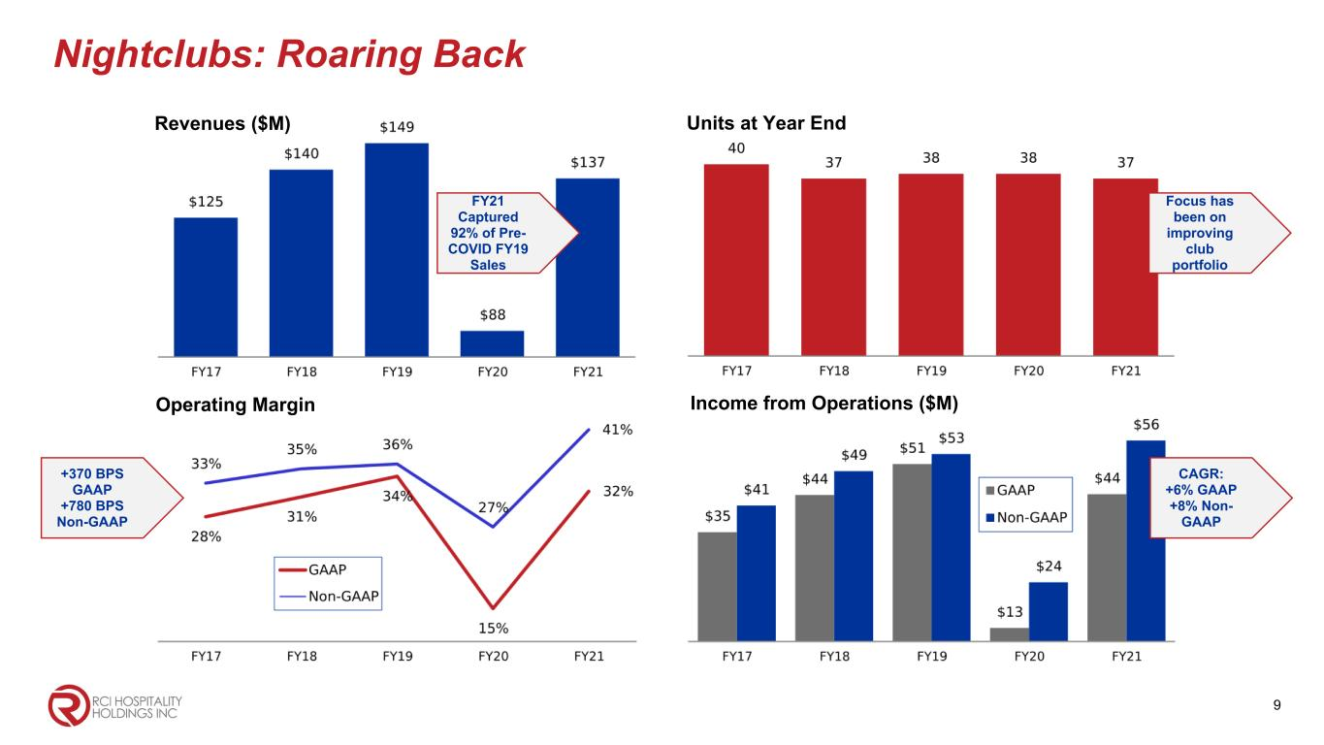
Nightclubs: Roaring Back Revenues ($M) Operating Margin 9 Income from Operations ($M) Units at Year End FY21 Captured 92% of Pre- COVID FY19 Sales +370 BPS GAAP +780 BPS Non-GAAP Focus has been on improving club portfolio CAGR: +6% GAAP +8% Non- GAAP

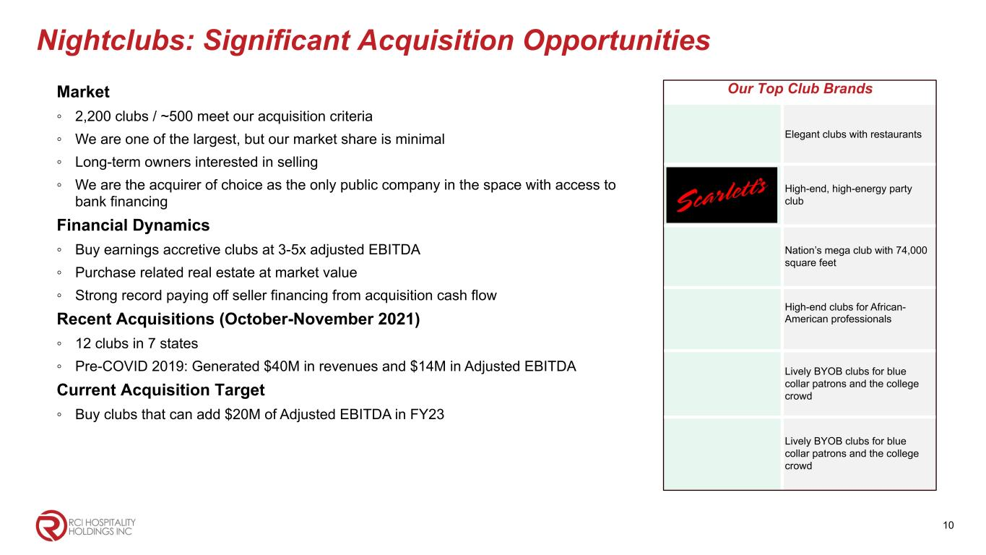
Nightclubs: Significant Acquisition Opportunities Market ◦ 2,200 clubs / ~500 meet our acquisition criteria ◦ We are one of the largest, but our market share is minimal ◦ Long-term owners interested in selling ◦ We are the acquirer of choice as the only public company in the space with access to bank financing Financial Dynamics ◦ Buy earnings accretive clubs at 3-5x adjusted EBITDA ◦ Purchase related real estate at market value ◦ Strong record paying off seller financing from acquisition cash flow Recent Acquisitions (October-November 2021) ◦ 12 clubs in 7 states ◦ Pre-COVID 2019: Generated $40M in revenues and $14M in Adjusted EBITDA Current Acquisition Target ◦ Buy clubs that can add $20M of Adjusted EBITDA in FY23 Our Top Club Brands Elegant clubs with restaurants High-end, high-energy party club Nation’s mega club with 74,000 square feet High-end clubs for African- American professionals Lively BYOB clubs for blue collar patrons and the college crowd Lively BYOB clubs for blue collar patrons and the college crowd 10

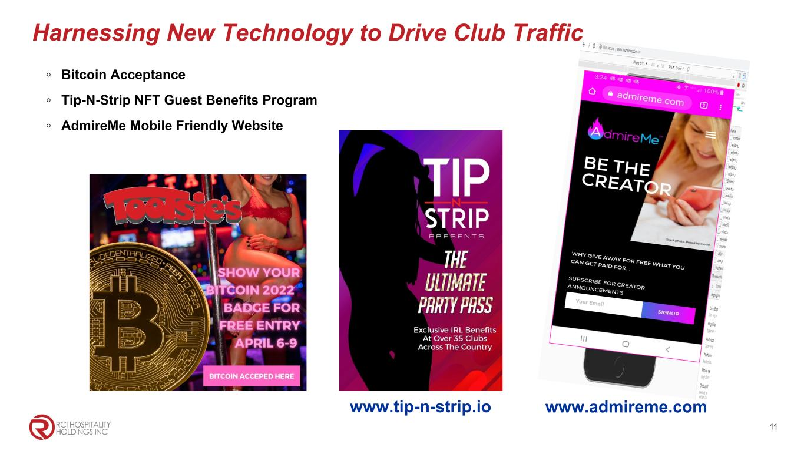
11 ◦ Bitcoin Acceptance ◦ Tip-N-Strip NFT Guest Benefits Program ◦ AdmireMe Mobile Friendly Website Harnessing New Technology to Drive Club Traffic www.tip-n-strip.io www.admireme.com

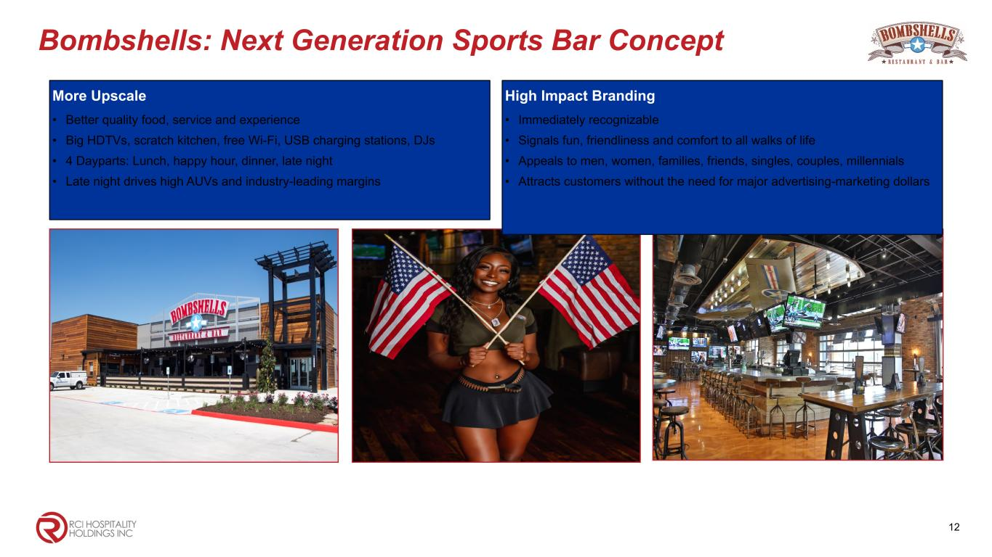
Bombshells: Next Generation Sports Bar Concept More Upscale • Better quality food, service and experience • Big HDTVs, scratch kitchen, free Wi-Fi, USB charging stations, DJs • 4 Dayparts: Lunch, happy hour, dinner, late night • Late night drives high AUVs and industry-leading margins 12 High Impact Branding • Immediately recognizable • Signals fun, friendliness and comfort to all walks of life • Appeals to men, women, families, friends, singles, couples, millennials • Attracts customers without the need for major advertising-marketing dollars

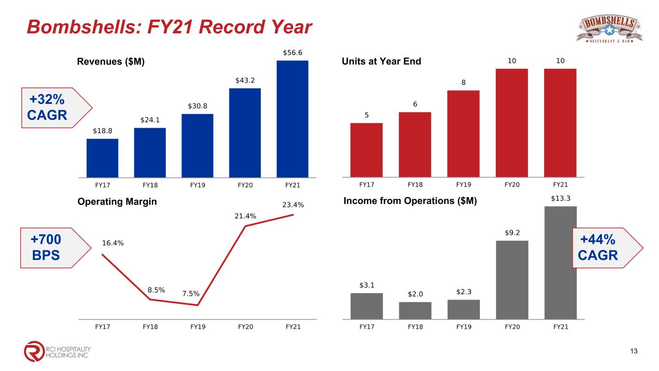
Bombshells: FY21 Record Year Revenues ($M) Operating Margin 13 Income from Operations ($M) Units at Year End +32% CAGR +700 BPS +44% CAGR

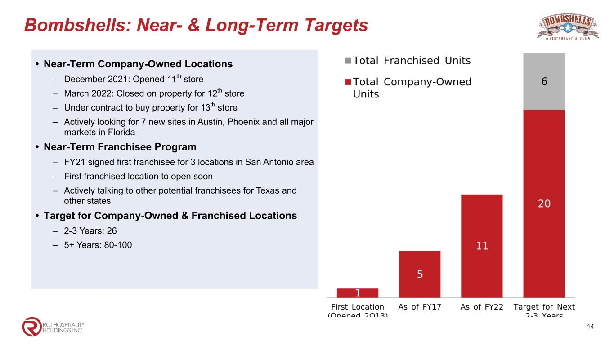
Bombshells: Near- & Long-Term Targets • Near-Term Company-Owned Locations – December 2021: Opened 11th store – March 2022: Closed on property for 12th store – Under contract to buy property for 13th store – Actively looking for 7 new sites in Austin, Phoenix and all major markets in Florida • Near-Term Franchisee Program – FY21 signed first franchisee for 3 locations in San Antonio area – First franchised location to open soon – Actively talking to other potential franchisees for Texas and other states • Target for Company-Owned & Franchised Locations – 2-3 Years: 26 – 5+ Years: 80-100 14


Corporate Office 10737 Cutten Road Houston, TX 77066 Phone: (281) 397-6730 Investor Relations Gary Fishman Steven Anreder Phone: (212) 532-3232 IR Website www.rcihospitality.com Nasdaq: RICK Contact Information

