United States
Securities and Exchange Commission
Washington, D.C. 20549
FORM 8-K
Current Report
Pursuant to Section 13 or 15(d) of
The Securities Exchange Act of 1934
Date of Report (Date of earliest event reported): May 9, 2022
RCI HOSPITALITY HOLDINGS, INC.
(Exact Name of Registrant as Specified in Its Charter)

Texas |  |  | 001-13992 |  |  | 76-0458229
(State or Other Jurisdiction  of Incorporation) |  |  | (Commission  File Number) |  |  | (IRS Employer  Identification No.)
10737 Cutten Road
Houston, Texas 77066
(Address of Principal Executive Offices, Including Zip Code)
(281) 397-6730
(Issuer’s Telephone Number, Including Area Code)
Check the appropriate box below if the Form 8-K filing is intended to simultaneously satisfy the filing obligation of the registrant under any of the following provisions:

o |  |  | Written communications pursuant to Rule 425 under the Securities Act (17 CFR 230.425)
o |  |  | Soliciting material pursuant to Rule 14a-12 under the Exchange Act (17 CFR 240.14a -12)
o |  |  | Pre-commencement communications pursuant to Rule 14d-2(b) under the Exchange Act (17 CFR 240.14d -2(b))
o |  |  | Pre-commencement communications pursuant to Rule 13e-4(c) under the Exchange Act (17 CFR 240.13e -4(c))
Securities registered pursuant to Section 12(b) of the Act:

Title of each class |  |  |  |  |  | Trading Symbol(s) |  |  |  |  |  | Name of each exchange on which registered
Common stock, $0.01 par value |  |  |  |  |  | RICK |  |  |  |  |  | The Nasdaq Global Market
Indicate by check mark whether the registrant is an emerging growth company as defined in Rule 405 of the Securities Act of 1933 (§230.405 of this chapter) or Rule 12b-2 of the Securities Exchange Act of 1934 (§240.12b-2 of this chapter).
Emerging growth company o
If an emerging growth company, indicate by check mark if the registrant has elected not to use the extended transition period for complying with any new or revised financial accounting standards provided pursuant to Section 13(a) of the Exchange Act. o

ITEM 2.02 RESULTS OF OPERATIONS AND FINANCIAL CONDITION.

On May 9, 2022, we issued a press release announcing the filing of our quarterly report on Form 10-Q for the fiscal quarter ended March 31, 2022 and announced results for the fiscal quarter ended March 31, 2022. Also on May 9, 2022, we will hold a conference call to discuss these results and related matters. A copy of the press release is furnished as Exhibit 99.1 to this current report on Form 8-K.

This information shall not be deemed “filed” for purposes of Section 18 of the Securities Exchange Act of 1934, as amended (the “Exchange Act”), or incorporated by reference in any filing under the Securities Act of 1933, as amended, or the Exchange Act, except as shall be expressly set forth by specific reference in such a filing.

ITEM 9.01 FINANCIAL STATEMENTS AND EXHIBITS

(d) Exhibits

Exhibit Number |  |  |  |  |  | Description
99.1 |  |  |  |  |  | Press release of RCI Hospitality Holdings, Inc. dated May 9, 2022
104 |  |  |  |  |  | Cover Page Interactive Data File (embedded within the Inline XBRL document)
2

SIGNATURES
Pursuant to the requirements of the Securities Exchange Act of 1934, the registrant has duly caused this report to be signed on its behalf by the undersigned hereunto duly authorized.

 |  |  | RCI HOSPITALITY HOLDINGS, INC.
Date: May 9, 2022 |  |  | By: |  |  | /s/ Eric Langan
 |  |  |  |  |  | Eric Langan
 |  |  |  |  |  | President and Chief Executive Officer
3


RCI Reports 2Q22 Results: Total Revenues $63.7M, GAAP EPS $1.15, Non-GAAP EPS $1.19
First Company to Use Twitter Spaces for Earnings Call – Today at 4:30 PM ET
HOUSTON—May 9, 2022—RCI Hospitality Holdings, Inc. (Nasdaq: RICK) today reported results and filed its Form 10-Q for the fiscal 2022 second quarter and six months ended March 31, 2022.

Summary Financials |  |  | 2Q22 |  |  | Change YoY |  |  | 6M22 |  |  | Change YoY
Total Revenues |  |  | $63.7M |  |  | +44.6% |  |  | $125.5M |  |  | +52.2%
EPS |  |  | $1.15 |  |  | +69.1% |  |  | $2.28 |  |  | +30.3%
Non-GAAP EPS* |  |  | $1.19 |  |  | +58.0% |  |  | $2.29 |  |  | +100.1%
Net Cash from Operating Activities |  |  | $11.6M |  |  | +5.7% |  |  | $27.9M |  |  | +61.6%
Free Cash Flow* |  |  | $11.1M |  |  | +23.3% |  |  | $26.3M |  |  | +79.8%
Net Income Attributable to RCIHH Common Stockholders |  |  | $11.0M |  |  | +79.8% |  |  | $21.5M |  |  | +36.8%
Adjusted EBITDA* |  |  | $19.9M |  |  | +46.8% |  |  | $37.9M |  |  | +70.2%
Diluted Shares |  |  | 9.489M |  |  | +5.4% |  |  | 9.448M |  |  | +4.9%
* See “Non-GAAP Financial Measures” below.
Eric Langan, President and CEO of RCI Hospitality Holdings, Inc., stated: “We had an outstanding quarter across the board. We ended the quarter with $38.1 million in cash, and favorable trends are continuing, with total revenues in April exceeding March. Thanks to all our teams for making all of this possible.”
Expansion efforts are moving ahead. This includes continuing to improve the performance of clubs acquired in 1Q22, acquiring new ones, harnessing new technology to drive club traffic, and expanding Bombshells. Recent developments:
Nightclubs
•South Florida club acquired last week
•Fort Worth club under contract to buy
•New Rick’s Steakhouse & Lounge opened in Miami
•Reformatted club opening soon in San Antonio
•AdmireMe.com social media fan site in full beta
•Tip-N-Strip non-fungible token (NFT) guest benefits program on track to mint in June
Bombshells
•Property acquired for a 12th Bombshells (Houston)
•Two other locations (Dallas and Lubbock, TX) under contract to buy
•Bombshells’ first franchisee expected to open its first location in San Antonio this quarter
•Bombshells’ second franchisee (announced last week) planning its first location for Huntsville, Alabama
Conference Call Today at 4:30 PM ET
Participants need to use Twitter Spaces on their mobile phones to ask questions during the Q&A

Twitter |  |  | Telephone |  |  | Webcast
•To participate in the RCI 2Q22 Earnings Call Twitter Space, follow @RicksCEO and go to this link: https://twitter.com/i/spaces/1mrGmanekZQGy |  |  | •Live: Toll Free 888-506-0062, Intl. 973-528-0011, Passcode: 384318  •Replay: Toll Free 877-481-4010, Intl. 919-882-2331, Passcode: 45285 |  |  | •Live webcast, slides & replay: https://www.webcaster4.com/Webcast/Page/2209/45285
Meet Management Tonight at 8:00 PM ET
•Investors are invited to meet management at RCI’s top revenue generating club
•Tootsie’s Cabaret Miami, 150 NW 183rd St., Miami, FL 33169
•To be on the guest list, RSVP your contact information to gary.fishman@anreder.com by 5:00 PM ET today
1

2Q22 Segments
Nightclubs
•Revenues of $48.2 million increased by 56.5% compared to the prior-year quarter, when COVID-19 related government restrictions were just starting to ease.
•Newly acquired clubs contributed 50% of the $17.4 million increase in segment revenues. Same-store sales growth contributed 20%, and eight northern clubs (not open enough days in 2Q21 to qualify for same-store sales) contributed 30%.
•Operating margin was 39.7% vs. 34.0% in 2Q21 and 39.5% vs. 38.8% non-GAAP. Operating margin expanded primarily due to an 88% year-over-year increase in high-margin service revenues.
Bombshells
•Revenues of $15.3 million increased by 16.7% compared to the prior-year quarter.
•Bombshells Arlington, which opened in December, contributed 85% of the $2.2 million segment revenue increase. Same-store sales growth contributed 14%.
•Operating margin was 22.6% vs. 23.9% in the year ago quarter and 19.0% in the previous quarter, which was negatively affected by Arlington’s pre-opening costs without the benefit of a full quarter of sales.
2Q22 Consolidated
Comparisons are to 2Q21 and % are of total revenues unless indicated otherwise
•Cost of goods sold improved (13.8% vs. 15.4%), reflecting the increase in sales mix of higher-margin service revenues (33.8% vs. 26.1%).
•Salaries and wages (26.0% vs. 25.4%) and SG&A (28.9% vs. 28.6%) were approximately level, reflecting new employees from new units and increased variable expenses related to sales in 2Q22.
•Operating margin was 26.8% vs. 22.3% and 26.9% vs. 25.9% non-GAAP.
•Interest expense increased $500,000 primarily due to higher debt related to the 1Q22 acquisitions, but declined to 4.5% from 5.4% of revenues.
•Income tax expense was $3.4 million compared to $1.9 million. The effective tax rate was 23.4% vs. 24.3%.
•Weighted average shares outstanding increased 5.4% due to shares issued for clubs acquired in 1Q22.
•83,343 shares were bought back in the open market 2Q22 and 3Q22 through May 6, 2022, for $5.2 million, or an average of $62.37 per share.
•Debt was $178.1 million at 3/31/22 compared to $161.9 million at 12/31/21. The increase primarily reflected the January 2022 bank loan secured by real estate, most of which was acquired for cash in acquisitions.
Note
As of the release of this report, we do not know the future extent and duration of the impact of COVID-19 on our businesses. We will continually monitor and evaluate our cash flow situation to determine whether any measures need to be instituted. All references to the “company,” “we,” “our,” and similar terms include RCI Hospitality Holdings, Inc., and its subsidiaries, unless the context indicates otherwise.
Non-GAAP Financial Measures
In addition to our financial information presented in accordance with GAAP, management uses certain non-GAAP financial measures, within the meaning of the SEC Regulation G, to clarify and enhance understanding of past performance and prospects for the future. Generally, a non-GAAP financial measure is a numerical measure of a company’s operating performance, financial position or cash flows that excludes or includes amounts that are included in or excluded from the most directly comparable measure calculated and presented in accordance with GAAP. We monitor non-GAAP financial measures because it describes the operating performance of the Company and helps management and investors gauge our ability to generate cash flow, excluding (or including) some items that management believes are not representative of the ongoing business operations of the Company, but are included in (or excluded from) the most directly comparable measures calculated and presented in accordance with GAAP. Relative to each of the non-GAAP financial measures, we further set forth our rationale as follows:

2

•Non-GAAP Operating Income and Non-GAAP Operating Margin. We calculate non-GAAP operating income and non-GAAP operating margin by excluding the following items from income from operations and operating margin: (a) amortization of intangibles, (b) gains or losses on sale of businesses and assets, (c) gains or losses on insurance, and (d) settlement of lawsuits. We believe that excluding these items assists investors in evaluating period-over-period changes in our operating income and operating margin without the impact of items that are not a result of our day-to-day business and operations.
•Non-GAAP Net Income and Non-GAAP Net Income per Diluted Share. We calculate non-GAAP net income and non-GAAP net income per diluted share by excluding or including certain items to net income attributable to RCIHH common stockholders and diluted earnings per share. Adjustment items are: (a) amortization of intangibles, (b) impairment of assets, (c) gains or losses on sale of businesses and assets, (d) gains or losses on insurance, (e) unrealized gains or losses on equity securities, (f) settlement of lawsuits, (g) gain on debt extinguishment, and (h) the income tax effect of the above-described adjustments. Included in the income tax effect of the above adjustments is the net effect of the non-GAAP provision for income taxes, calculated at 21.8% and 24.2% effective tax rate of the pre-tax non-GAAP income before taxes for the six months ended March 31, 2022 and 2021, respectively, and the GAAP income tax expense (benefit). We believe that excluding and including such items help management and investors better understand our operating activities.
•Adjusted EBITDA. We calculate adjusted EBITDA by excluding the following items from net income attributable to RCIHH common stockholders: (a) depreciation and amortization, (b) income tax expense (benefit), (c) net interest expense, (d) gains or losses on sale of businesses and assets, (e) gains or losses on insurance, (f) unrealized gains or losses on equity securities, (g) impairment of assets, (h) settlement of lawsuits, and (i) gain on debt extinguishment. We believe that adjusting for such items helps management and investors better understand our operating activities. Adjusted EBITDA provides a core operational performance measurement that compares results without the need to adjust for federal, state and local taxes which have considerable variation between domestic jurisdictions. The results are, therefore, without consideration of financing alternatives of capital employed. We use adjusted EBITDA as one guideline to assess our unleveraged performance return on our investments. Adjusted EBITDA is also the target benchmark for our acquisitions of nightclubs.
•Management also uses non-GAAP cash flow measures such as free cash flow. Free cash flow is derived from net cash provided by operating activities less maintenance capital expenditures. We use free cash flow as the baseline for the implementation of our capital allocation strategy.
About RCI Hospitality Holdings, Inc. (Nasdaq: RICK) www.rcihospitality.com
With more than 50 units, RCI Hospitality Holdings, Inc., through its subsidiaries, is the country’s leading company in adult nightclubs and sports bars/restaurants. Clubs in New York City, Chicago, Dallas-Fort Worth, Houston, Miami, Minneapolis, Denver, St. Louis, Charlotte, Pittsburgh, Raleigh, Louisville, and other markets operate under brand names such as Rick's Cabaret, XTC, Club Onyx, Vivid Cabaret, Jaguars Club, Tootsie’s Cabaret, and Scarlett’s Cabaret. Sports bars/restaurants operate under the brand name Bombshells Restaurant & Bar.
Forward-Looking Statements
This press release may contain forward-looking statements that involve a number of risks and uncertainties that could cause the company’s actual results to differ materially from those indicated, including, but not limited to, the risks and uncertainties associated with (i) operating and managing an adult business, (ii) the business climates in cities where it operates, (iii) the success or lack thereof in launching and building the company’s businesses, (iv) cyber security, (v) conditions relevant to real estate transactions, (vi) the impact of the COVID-19 pandemic, and (vii) numerous other factors such as laws governing the operation of adult entertainment businesses, competition and dependence on key personnel. For more detailed discussion of such factors and certain risks and uncertainties, see RCI’s annual report on Form 10-K for the year ended September 30, 2021, as well as its other filings with the U.S. Securities and Exchange Commission. The company has no obligation to update or revise the forward-looking statements to reflect the occurrence of future events or circumstances.
Media & Investor Contacts
Gary Fishman and Steven Anreder at 212-532-3232 or gary.fishman@anreder.com and steven.anreder@anreder.com
3

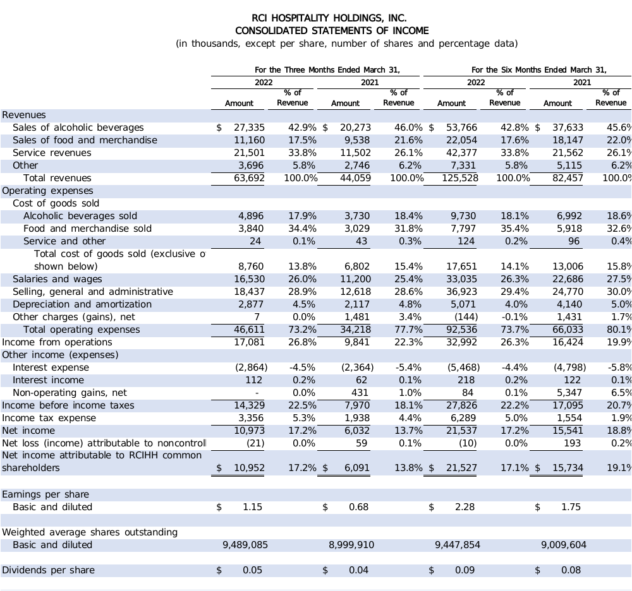

4

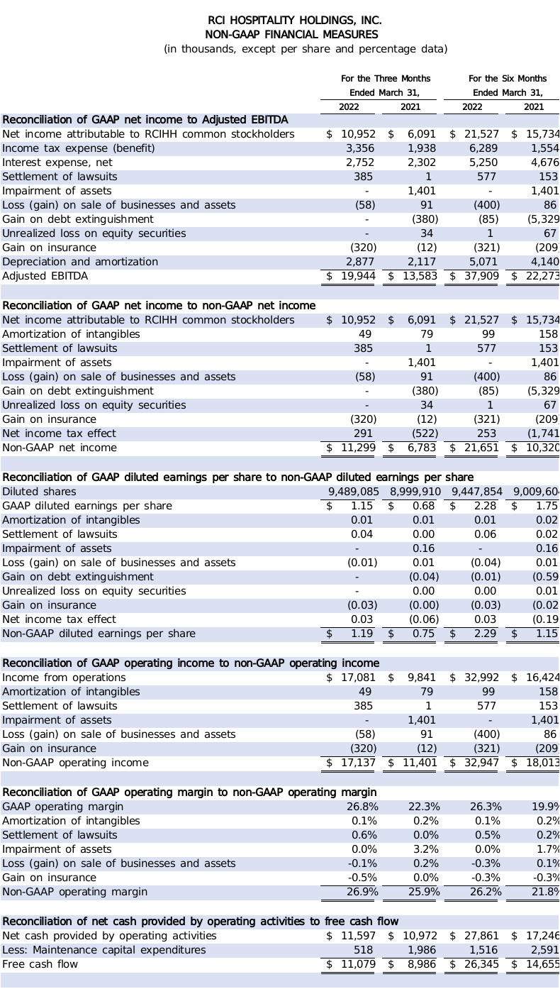
5

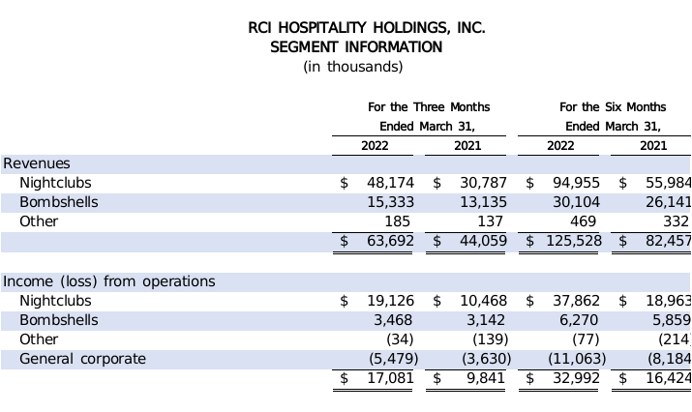
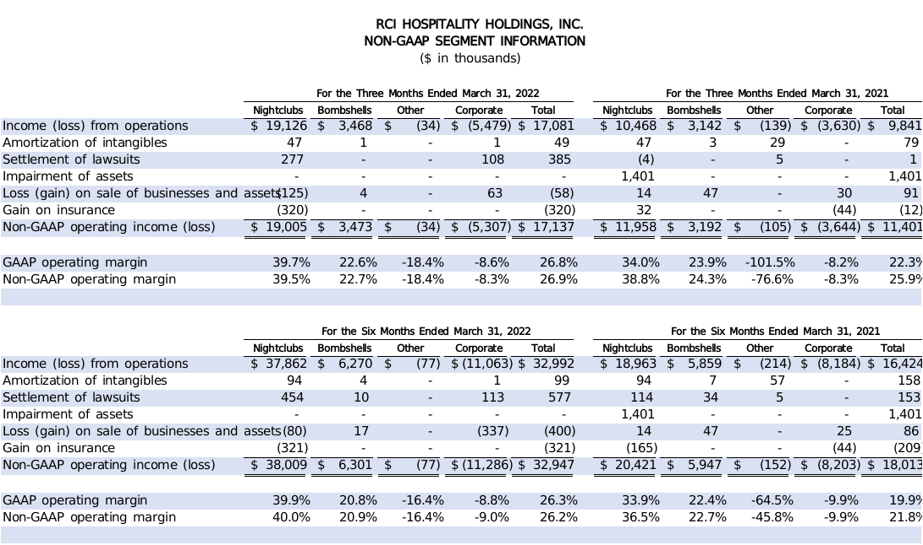
6

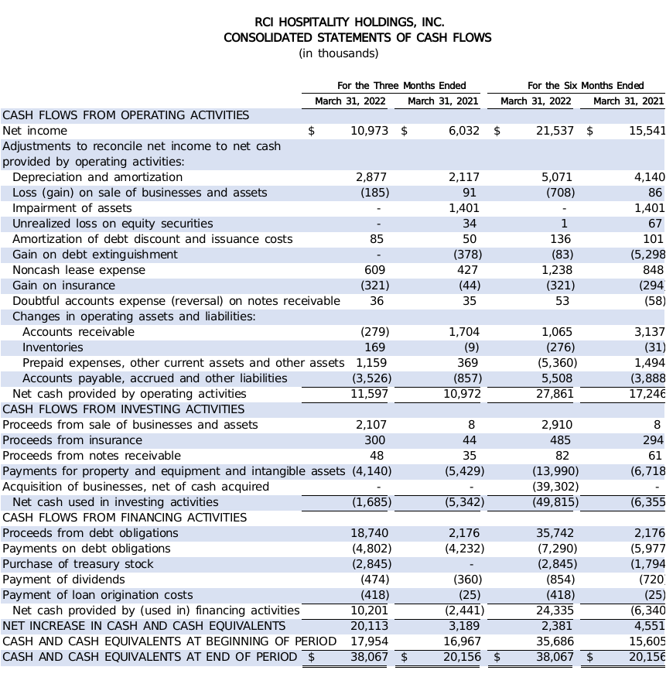
7

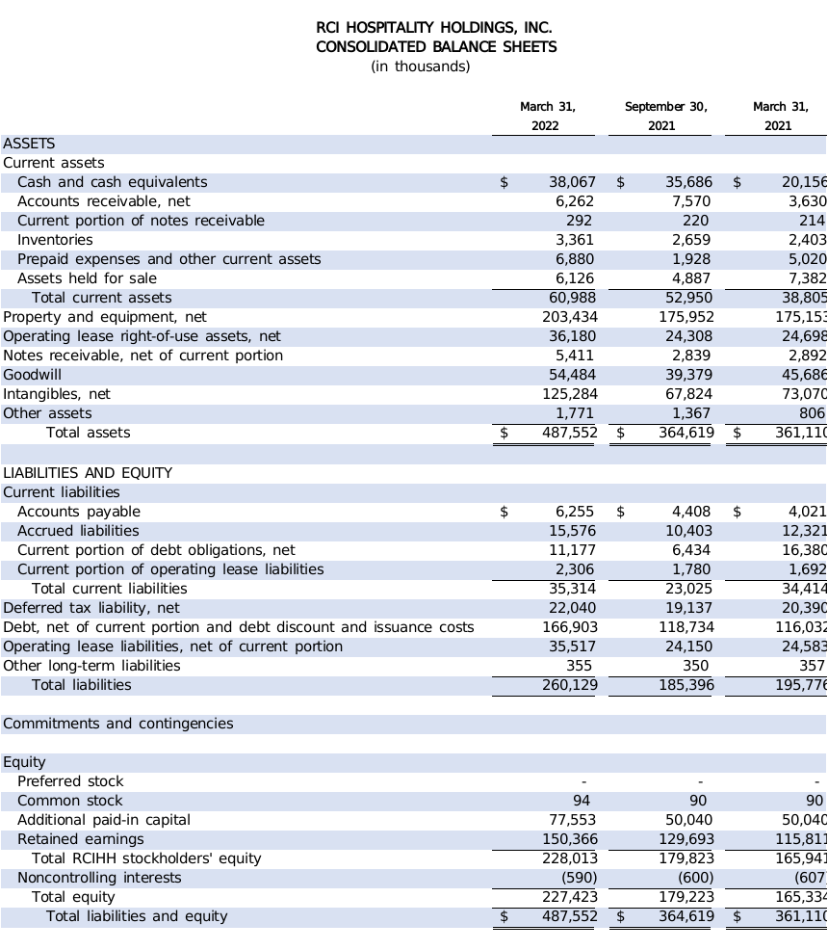
8

