United States
Securities and Exchange Commission
Washington, D.C. 20549
FORM 8-K
Current Report
Pursuant to Section 13 or 15(d) of
The Securities Exchange Act of 1934
Date of Report (Date of earliest event reported): July 12, 2022
RCI HOSPITALITY HOLDINGS, INC.
(Exact Name of Registrant as Specified in Its Charter)

Texas |  |  | 001-13992 |  |  | 76-0458229
(State or Other Jurisdiction  of Incorporation) |  |  | (Commission  File Number) |  |  | (IRS Employer  Identification No.)
10737 Cutten Road
Houston, Texas 77066
(Address of Principal Executive Offices, Including Zip Code)
(281) 397-6730
(Issuer’s Telephone Number, Including Area Code)
Check the appropriate box below if the Form 8-K filing is intended to simultaneously satisfy the filing obligation of the registrant under any of the following provisions:

o |  |  | Written communications pursuant to Rule 425 under the Securities Act (17 CFR 230.425)
o |  |  | Soliciting material pursuant to Rule 14a-12 under the Exchange Act (17 CFR 240.14a -12)
o |  |  | Pre-commencement communications pursuant to Rule 14d-2(b) under the Exchange Act (17 CFR 240.14d -2(b))
o |  |  | Pre-commencement communications pursuant to Rule 13e-4(c) under the Exchange Act (17 CFR 240.13e -4(c))
Securities registered pursuant to Section 12(b) of the Act:

Title of each class |  |  |  |  |  | Trading Symbol(s) |  |  |  |  |  | Name of each exchange on which registered
Common stock, $0.01 par value |  |  |  |  |  | RICK |  |  |  |  |  | The Nasdaq Global Market
Indicate by check mark whether the registrant is an emerging growth company as defined in Rule 405 of the Securities Act of 1933 (§230.405 of this chapter) or Rule 12b-2 of the Securities Exchange Act of 1934 (§240.12b-2 of this chapter).
Emerging growth company o
If an emerging growth company, indicate by check mark if the registrant has elected not to use the extended transition period for complying with any new or revised financial accounting standards provided pursuant to Section 13(a) of the Exchange Act. o

ITEM 2.02 RESULTS OF OPERATIONS AND FINANCIAL CONDITION.

On July 12, 2022, we issued a press release announcing sales at nightclubs and restaurants and share buybacks for the third fiscal quarter ended June 30, 2022. Also on July 12, 2022, we will hold a conference call to discuss these sales numbers and related matters. A copy of the press release is furnished as Exhibit 99.1 to this current report on Form 8-K, and a copy of the presentation slides is furnished with this current report as Exhibit 99.2.

This information shall not be deemed “filed” for purposes of Section 18 of the Securities Exchange Act of 1934, as amended (the “Exchange Act”), or incorporated by reference in any filing under the Securities Act of 1933, as amended, or the Exchange Act, except as shall be expressly set forth by specific reference in such a filing.

ITEM 9.01 FINANCIAL STATEMENTS AND EXHIBITS

(d) Exhibits

Exhibit Number |  |  |  |  |  | Description
99.1 |  |  |  |  |  | Press release of RCI Hospitality Holdings, Inc. dated July 12, 2022
99.2 |  |  |  |  |  | Presentation Slides
104 |  |  |  |  |  | Cover Page Interactive Data File (embedded within the Inline XBRL document)
2

SIGNATURES
Pursuant to the requirements of the Securities Exchange Act of 1934, the registrant has duly caused this report to be signed on its behalf by the undersigned hereunto duly authorized.

 |  |  | RCI HOSPITALITY HOLDINGS, INC.
Date: July 12, 2022 |  |  | By: |  |  | /s/ Eric Langan
 |  |  |  |  |  | Eric Langan
 |  |  |  |  |  | President and Chief Executive Officer
3


RCI Reports 3Q22 Club & Restaurant Sales and Share Buybacks
Twitter Spaces Conference Call Today at 10:30 AM ET
HOUSTON—July 12, 2022—RCI Hospitality Holdings, Inc. (Nasdaq: RICK) reported sales for its Nightclubs and Bombshells restaurants of $70.1 million for the fiscal third quarter ended June 30, 2022. Sales do not include non-core operations and are preliminary and subject to final closing. Full 3Q22 financial results are expected by August 9. RCI also announced it bought back 168,069 shares in 3Q22 totaling $9.2 million.
Eric Langan, President and CEO of RCI Hospitality Holdings, Inc., EVP Travis Reese, and CFO Bradley Chhay will participate in a Twitter Spaces conference call regarding today’s news at 10:30 AM ET. The Twitter Spaces call will be hosted by Mr. Langan; co-hosted by WOLF Financial and Mark Moran of Litquidity; and accessible at https://twitter.com/i/spaces/1lDGLLLYMQwGm. A replay will be available immediately thereafter.
“We’re pleased revenues hit the higher end of our target annual run rate of $260-$280 million,” Mr. Langan said. “The third quarter was the first period since 1Q20 not affected by COVID. It also benefitted from the full integration of our 1Q22 club acquisitions. Bombshells faced comparisons to an unusually strong year-ago quarter, when it was one of the few bar and restaurant chains open in Texas, with little competition due to the state of COVID at the time. Otherwise, Bombshells saw typical seasonal trends. Armed with high cash balances from strong sales, we took advantage of market conditions to repurchase 1.78% of shares outstanding since March 31, 2022, and we ended the quarter with $37.5 million cash and cash equivalents.”
Club & Restaurant Sales ($ in Millions)

 |  |  | 3Q22 Total Sales |  |  | Total Sales vs. 3Q21 |  |  | Same-Store Sales vs. 3Q21
Combined |  |  | $70.1 |  |  | +23.7% |  |  | -0.1%
Nightclubs |  |  | $54.3 |  |  | +33.8% |  |  | +4.8%
Bombshells |  |  | $15.8 |  |  | -1.9% |  |  | -12.3%

 |  |  | 9M22 Total Sales |  |  | Total Sales vs. 9M21 |  |  | Same-Store Sales vs. 9M21
Combined |  |  | $194.3 |  |  | +40.7% |  |  | +8.4%
Nightclubs |  |  | $148.4 |  |  | +54.9% |  |  | +13.2%
Bombshells |  |  | $45.9 |  |  | +8.7% |  |  | -1.6%
Share Buybacks

 |  |  | 3Q22 |  |  | 9M22 |  |  | FY16-9M22
Repurchased Shares |  |  | 168,069 |  |  | 213,712 |  |  | 1,769,279
Total Cash Used for Repurchase ($M) |  |  | $9.2 |  |  | $12.1 |  |  | $34.6
Average Price Per Share |  |  | $54.81 |  |  | $56.42 |  |  | $19.58

1

Notes
Club acquisitions contributed sales of $11.8 million in 3Q22 and $27.0 million in 9M22. 11 clubs were acquired in October, one in November, and one in early May. Northern clubs continued to rebound. Clubs in key markets benefited from customer traffic related to major sporting events and NFT conferences.
Bombshells Arlington contributed sales of $1.7 million in 3Q22 and $4.3 million since its December opening. Bombshells’ first franchisee in San Antonio has seen very strong sales since opening June 27.
The COVID pandemic first impacted sales in RCI’s 2Q20. All locations were required to close mid-March 2020. Bombshells and some Nightclubs began to reopen May 2020. All Nightclubs were not fully reopened to their full operating hours until 4Q21.
All references to “RCI Hospitality Holdings, Inc.,” “company,” “we,” “our,” and similar terms refer to RCI and/or its subsidiaries, unless the context indicates otherwise.
About RCI Hospitality Holdings, Inc. (Nasdaq: RICK) www.rcihospitality.com
With more than 50 units, RCI Hospitality Holdings, Inc., through its subsidiaries, is the country’s leading company in adult nightclubs and sports bars/restaurants. Clubs in New York City, Chicago, Dallas-Fort Worth, Houston, Miami, Minneapolis, Denver, St. Louis, Charlotte, Pittsburgh, Raleigh, Louisville, and other markets operate under brand names such as Rick's Cabaret, XTC, Club Onyx, Vivid Cabaret, Jaguars Club, Tootsie’s Cabaret, and Scarlett’s Cabaret. Sports bars/restaurants operate under the brand name Bombshells Restaurant & Bar.
Forward-Looking Statements
This press release may contain forward-looking statements that involve a number of risks and uncertainties that could cause the company’s actual results to differ materially from those indicated, including, but not limited to, the risks and uncertainties associated with (i) operating and managing an adult business, (ii) the business climates in cities where it operates, (iii) the success or lack thereof in launching and building the company’s businesses, (iv) cyber security, (v) conditions relevant to real estate transactions, (vi) the impact of the COVID-19 pandemic, and (vii) numerous other factors such as laws governing the operation of adult entertainment businesses, competition and dependence on key personnel. For more detailed discussion of such factors and certain risks and uncertainties, see RCI’s annual report on Form 10-K for the year ended September 30, 2021, as well as its other filings with the U.S. Securities and Exchange Commission. The company has no obligation to update or revise the forward-looking statements to reflect the occurrence of future events or circumstances.
Media & Investor Contacts
Gary Fishman and Steven Anreder at 212-532-3232 or gary.fishman@anreder.com and steven.anreder@anreder.com
2

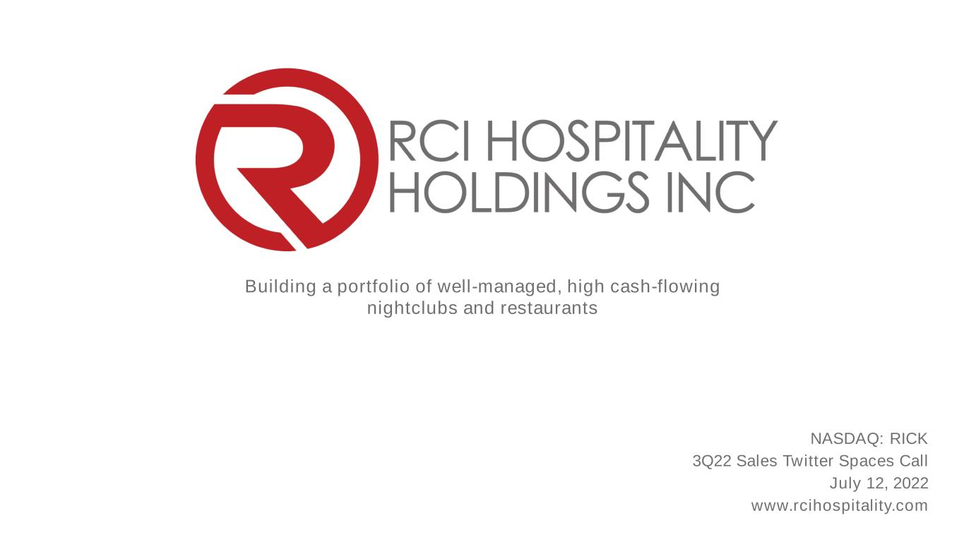
Building a portfolio of well-managed, high cash-flowing nightclubs and restaurants NASDAQ: RICK 3Q22 Sales Twitter Spaces Call July 12, 2022 www.rcihospitality.com

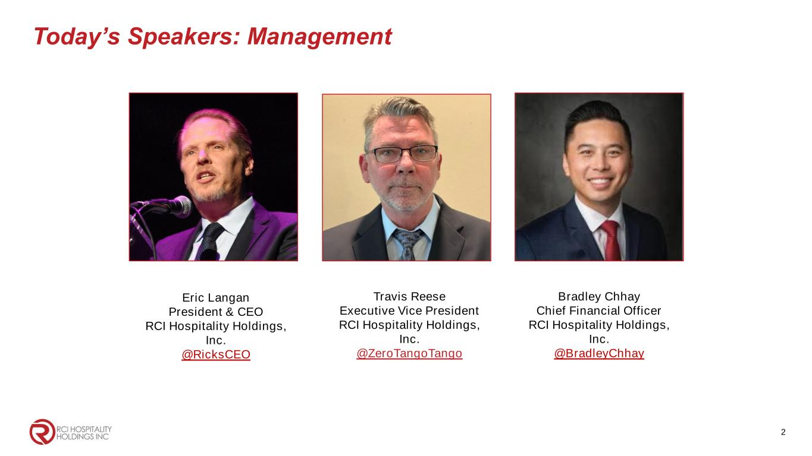
Today’s Speakers: Management 2 Eric Langan President & CEO RCI Hospitality Holdings, Inc. @RicksCEO Bradley Chhay Chief Financial Officer RCI Hospitality Holdings, Inc. @BradleyChhay Travis Reese Executive Vice President RCI Hospitality Holdings, Inc. @ZeroTangoTango

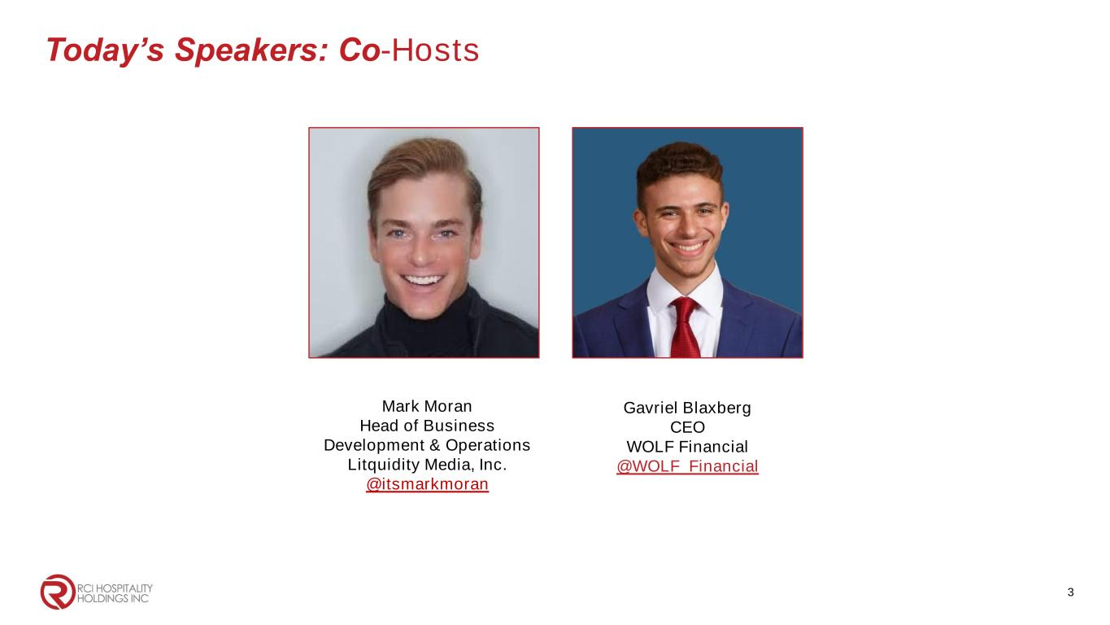
Today’s Speakers: Co-Hosts 3 Mark Moran Head of Business Development & Operations Litquidity Media, Inc. @itsmarkmoran Gavriel Blaxberg CEO WOLF Financial @WOLF_Financial

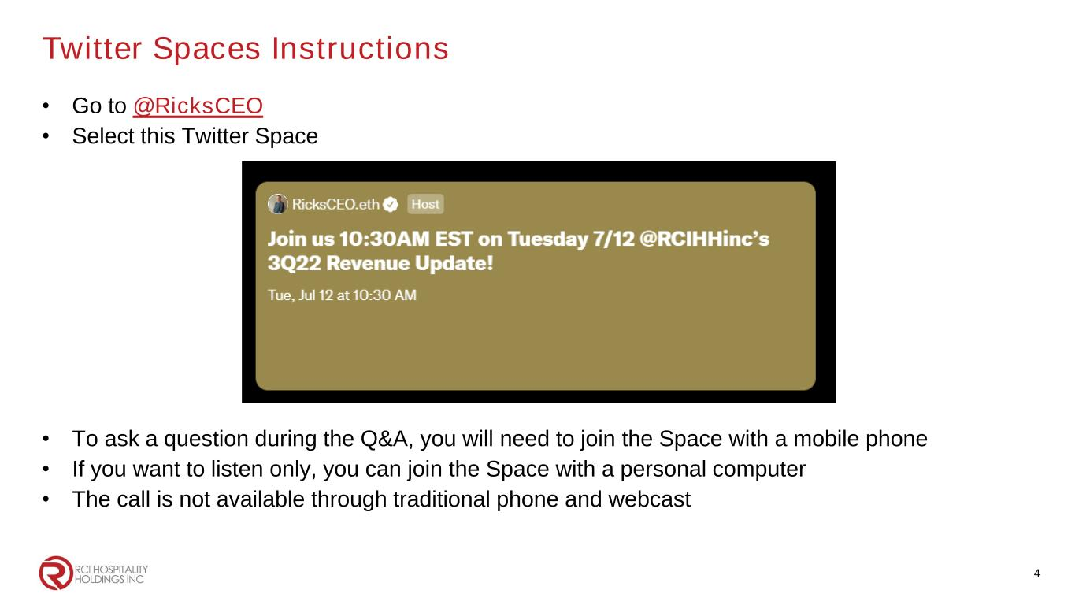
Twitter Spaces Instructions • Go to @RicksCEO • Select this Twitter Space • To ask a question during the Q&A, you will need to join the Space with a mobile phone • If you want to listen only, you can join the Space with a personal computer • The call is not available through traditional phone and webcast 4

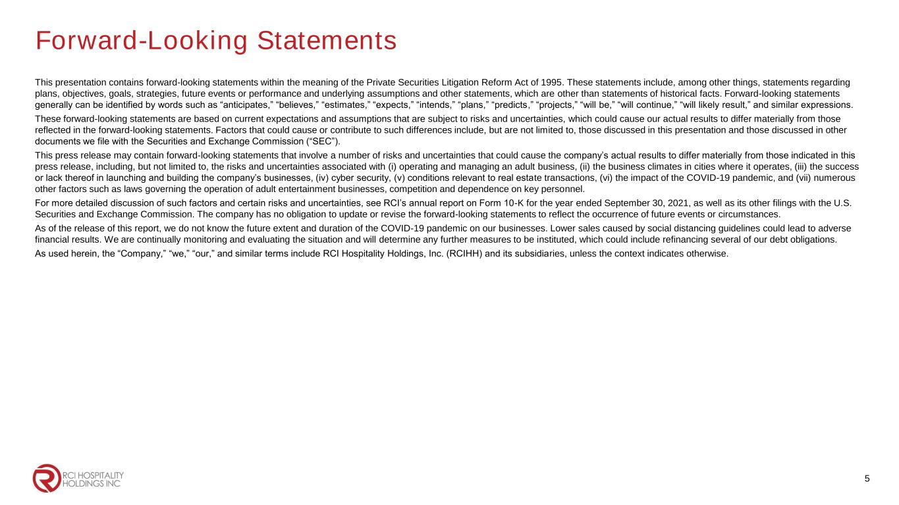
Forward-Looking Statements This presentation contains forward-looking statements within the meaning of the Private Securities Litigation Reform Act of 1995. These statements include, among other things, statements regarding plans, objectives, goals, strategies, future events or performance and underlying assumptions and other statements, which are other than statements of historical facts. Forward-looking statements generally can be identified by words such as “anticipates,” “believes,” “estimates,” “expects,” “intends,” “plans,” “predicts,” “projects,” “will be,” “will continue,” “will likely result,” and similar expressions. These forward-looking statements are based on current expectations and assumptions that are subject to risks and uncertainties, which could cause our actual results to differ materially from those reflected in the forward-looking statements. Factors that could cause or contribute to such differences include, but are not limited to, those discussed in this presentation and those discussed in other documents we file with the Securities and Exchange Commission (“SEC”). This press release may contain forward-looking statements that involve a number of risks and uncertainties that could cause the company’s actual results to differ materially from those indicated in this press release, including, but not limited to, the risks and uncertainties associated with (i) operating and managing an adult business, (ii) the business climates in cities where it operates, (iii) the success or lack thereof in launching and building the company’s businesses, (iv) cyber security, (v) conditions relevant to real estate transactions, (vi) the impact of the COVID-19 pandemic, and (vii) numerous other factors such as laws governing the operation of adult entertainment businesses, competition and dependence on key personnel. For more detailed discussion of such factors and certain risks and uncertainties, see RCI’s annual report on Form 10-K for the year ended September 30, 2021, as well as its other filings with the U.S. Securities and Exchange Commission. The company has no obligation to update or revise the forward-looking statements to reflect the occurrence of future events or circumstances. As of the release of this report, we do not know the future extent and duration of the COVID-19 pandemic on our businesses. Lower sales caused by social distancing guidelines could lead to adverse financial results. We are continually monitoring and evaluating the situation and will determine any further measures to be instituted, which could include refinancing several of our debt obligations. As used herein, the “Company,” “we,” “our,” and similar terms include RCI Hospitality Holdings, Inc. (RCIHH) and its subsidiaries, unless the context indicates otherwise. 5

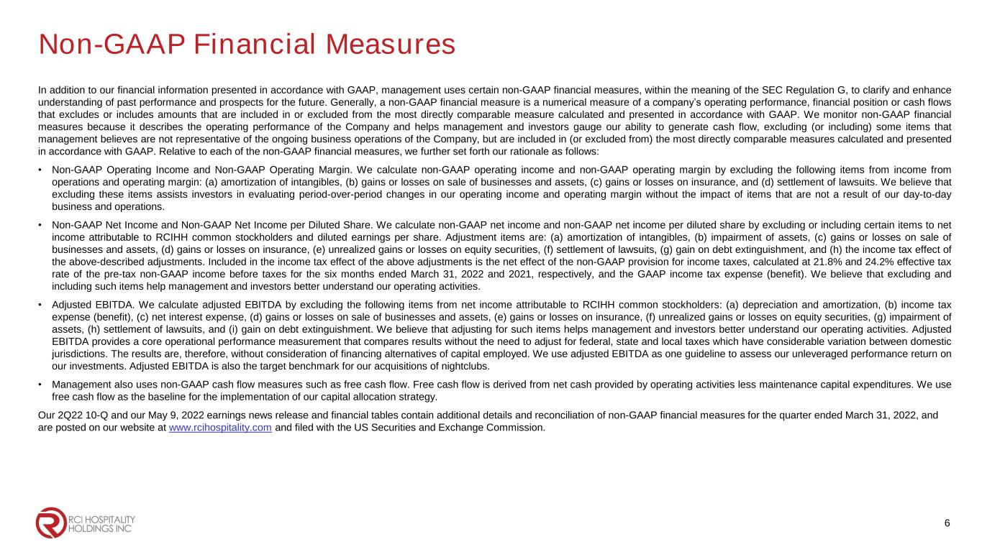
Non-GAAP Financial Measures In addition to our financial information presented in accordance with GAAP, management uses certain non-GAAP financial measures, within the meaning of the SEC Regulation G, to clarify and enhance understanding of past performance and prospects for the future. Generally, a non-GAAP financial measure is a numerical measure of a company’s operating performance, financial position or cash flows that excludes or includes amounts that are included in or excluded from the most directly comparable measure calculated and presented in accordance with GAAP. We monitor non-GAAP financial measures because it describes the operating performance of the Company and helps management and investors gauge our ability to generate cash flow, excluding (or including) some items that management believes are not representative of the ongoing business operations of the Company, but are included in (or excluded from) the most directly comparable measures calculated and presented in accordance with GAAP. Relative to each of the non-GAAP financial measures, we further set forth our rationale as follows: • Non-GAAP Operating Income and Non-GAAP Operating Margin. We calculate non-GAAP operating income and non-GAAP operating margin by excluding the following items from income from operations and operating margin: (a) amortization of intangibles, (b) gains or losses on sale of businesses and assets, (c) gains or losses on insurance, and (d) settlement of lawsuits. We believe that excluding these items assists investors in evaluating period-over-period changes in our operating income and operating margin without the impact of items that are not a result of our day-to-day business and operations. • Non-GAAP Net Income and Non-GAAP Net Income per Diluted Share. We calculate non-GAAP net income and non-GAAP net income per diluted share by excluding or including certain items to net income attributable to RCIHH common stockholders and diluted earnings per share. Adjustment items are: (a) amortization of intangibles, (b) impairment of assets, (c) gains or losses on sale of businesses and assets, (d) gains or losses on insurance, (e) unrealized gains or losses on equity securities, (f) settlement of lawsuits, (g) gain on debt extinguishment, and (h) the income tax effect of the above-described adjustments. Included in the income tax effect of the above adjustments is the net effect of the non-GAAP provision for income taxes, calculated at 21.8% and 24.2% effective tax rate of the pre-tax non-GAAP income before taxes for the six months ended March 31, 2022 and 2021, respectively, and the GAAP income tax expense (benefit). We believe that excluding and including such items help management and investors better understand our operating activities. • Adjusted EBITDA. We calculate adjusted EBITDA by excluding the following items from net income attributable to RCIHH common stockholders: (a) depreciation and amortization, (b) income tax expense (benefit), (c) net interest expense, (d) gains or losses on sale of businesses and assets, (e) gains or losses on insurance, (f) unrealized gains or losses on equity securities, (g) impairment of assets, (h) settlement of lawsuits, and (i) gain on debt extinguishment. We believe that adjusting for such items helps management and investors better understand our operating activities. Adjusted EBITDA provides a core operational performance measurement that compares results without the need to adjust for federal, state and local taxes which have considerable variation between domestic jurisdictions. The results are, therefore, without consideration of financing alternatives of capital employed. We use adjusted EBITDA as one guideline to assess our unleveraged performance return on our investments. Adjusted EBITDA is also the target benchmark for our acquisitions of nightclubs. • Management also uses non-GAAP cash flow measures such as free cash flow. Free cash flow is derived from net cash provided by operating activities less maintenance capital expenditures. We use free cash flow as the baseline for the implementation of our capital allocation strategy. Our 2Q22 10-Q and our May 9, 2022 earnings news release and financial tables contain additional details and reconciliation of non-GAAP financial measures for the quarter ended March 31, 2022, and are posted on our website at www.rcihospitality.com and filed with the US Securities and Exchange Commission. 6

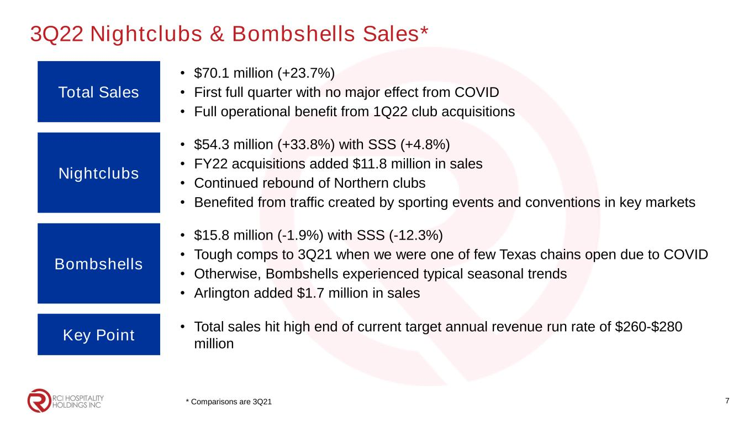
3Q22 Nightclubs & Bombshells Sales* Total Sales • $70.1 million (+23.7%) • First full quarter with no major effect from COVID • Full operational benefit from 1Q22 club acquisitions Nightclubs • $54.3 million (+33.8%) with SSS (+4.8%) • FY22 acquisitions added $11.8 million in sales • Continued rebound of Northern clubs • Benefited from traffic created by sporting events and conventions in key markets Bombshells • $15.8 million (-1.9%) with SSS (-12.3%) • Tough comps to 3Q21 when we were one of few Texas chains open due to COVID • Otherwise, Bombshells experienced typical seasonal trends • Arlington added $1.7 million in sales Key Point • Total sales hit high end of current target annual revenue run rate of $260-$280 million 7* Comparisons are 3Q21

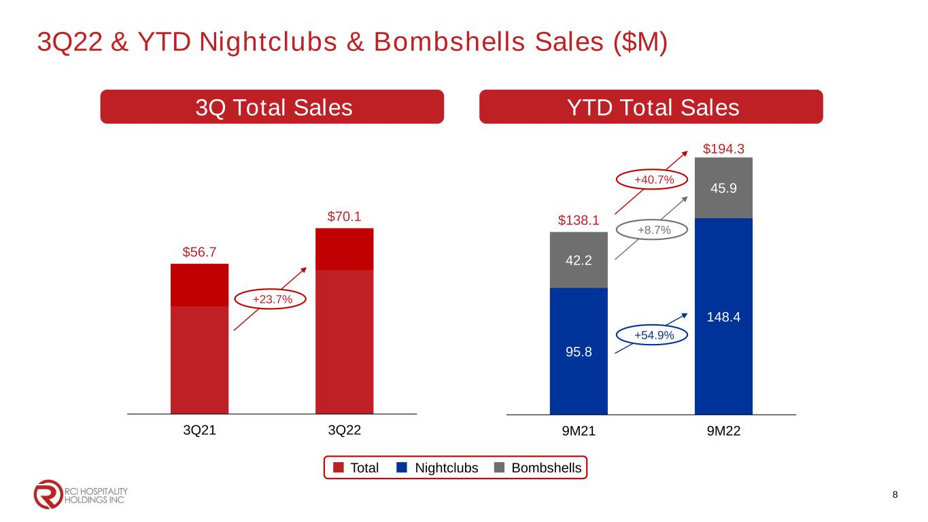
3Q22 & YTD Nightclubs & Bombshells Sales ($M) 8 Total Nightclubs Bombshells 3Q Total Sales $56.7 $70.1 3Q21 3Q22 +23.7% 95.8 148.4 42.2 45.9 $138.1 $194.3 9M21 9M22 YTD Total Sales +40.7% +8.7% +54.9%

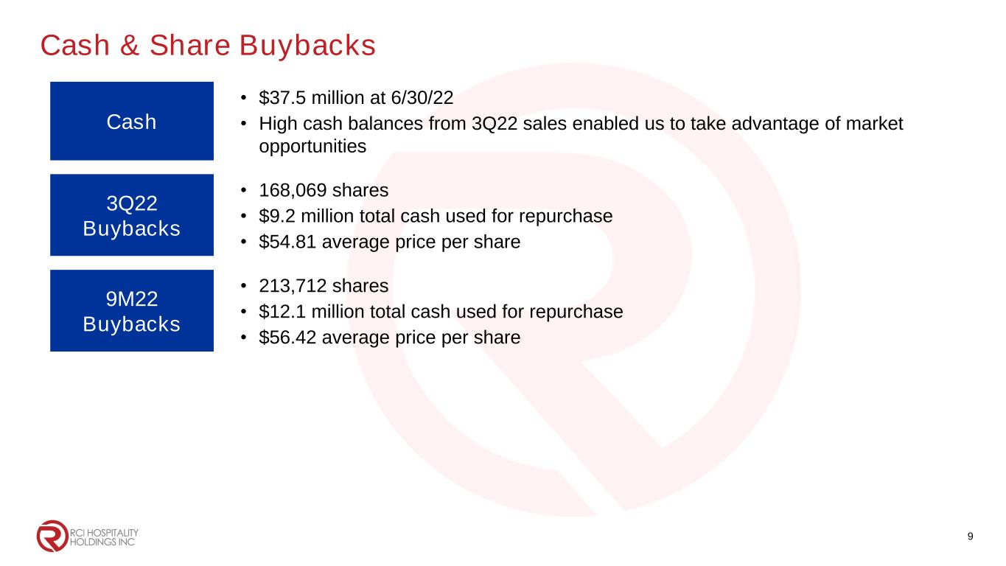
Cash & Share Buybacks Cash • $37.5 million at 6/30/22 • High cash balances from 3Q22 sales enabled us to take advantage of market opportunities 3Q22 Buybacks • 168,069 shares • $9.2 million total cash used for repurchase • $54.81 average price per share 9M22 Buybacks • 213,712 shares • $12.1 million total cash used for repurchase • $56.42 average price per share 9


Corporate Office 10737 Cutten Road Houston, TX 77066 Phone: (281) 397-6730 Investor Relations Gary Fishman Steven Anreder Phone: (212) 532-3232 IR Website www.rcihospitality.com Nasdaq: RICK Contact Information 10

